­­­

CampusNexus

Student Self-Service Admissions: Build a FERPA Process Using Forms Builder and Workflow

Campus Management Corp.

Web Site

[www.campusmanagement.com](http://www.campusmanagement.com/)

Contact Information

Phone: 1.561.923.2500

Sales/Support: 1.561.999.9904

Toll Free: 1.800.483.9106

Facsimile: 1.561.999.0096

Address

Campus Management Corp.

5201 Congress Ave

Boca Raton, FL 33487 USA

Copyright

© 2019 Campus Management Corp. All rights reserved. Campus Management Corp. and the Campus Management logo are trademarks or service marks of Campus Management Corp. These marks may be registered in the U.S. or other countries. All other registered trademarks and service marks are the properties of their respective owners.

Contents

Resources 1

Angular JS 1

Understanding OData 3

Validation Regex property in Forms Builder 3

Log File Location & Names 3

Agenda 4

Introduction 5

Course Objectives 5

Target Audience 5

Course Prerequisites 5

Lesson 1: Create a Student Self-Service Form and Supporting Workflow 6

Exercise: Create a FERPA Form and Supporting Workflow 6

Lesson 2: Validate the Form and Supporting Workflow 76

Exercise: Validate the Student Self-Service Form and Supporting Workflow for the FERPA Process 76

# Resources

[www.mycampusinsight.com](http://www.mycampusinsight.com)

**Note**: If you do not have a MyCampusInsight login, contact your Customer Enablement Manager.

<https://github.com/campusmanagement>

<http://community.campusmgmt.com>

## Angular JS

<https://docs.angularjs.org/guide/introduction>:

AngularJS is a structural framework for dynamic web apps. It lets you use HTML as your template language and lets you extend HTML's syntax to express your application's components clearly and succinctly. AngularJS's data binding and dependency injection eliminate much of the code you would otherwise have to write. In addition, it all happens within the browser, making it an ideal partner with any server technology.

AngularJS is what HTML would have been, had it been designed for applications. HTML is a great declarative language for static documents. It does not contain much in the way of creating applications, and as a result building web applications is an exercise in what do I have to do to trick the browser into doing what I want?

The impedance mismatch between dynamic applications and static documents is often solved with:

* **a library** - a collection of functions, which are useful when writing web apps. Your code is in charge and it calls into the library when it sees fit. E.g., jQuery.
* **frameworks** - a particular implementation of a web application, where your code fills in the details. The framework is in charge and it calls into your code when it needs something app specific. E.g., durandal, ember, etc.

AngularJS takes another approach. It attempts to minimize the impedance mismatch between document centric HTML and what an application needs by creating new HTML constructs. AngularJS teaches the browser new syntax through a construct we call directives. Examples include:

* Data binding, as in {{}}.
* DOM control structures for repeating, showing and hiding DOM fragments.
* Support for forms and form validation.
* Attaching new behavior to DOM elements, such as DOM event handling.
* Grouping of HTML into reusable components.

**Angular JS Resources**

<https://www.w3schools.com/js/js_comparisons.asp>

<https://teropa.info/images/angular_expressions_cheatsheet.pdf>

<https://docs.angularjs.org/guide/expression>

## Understanding OData

<http://www.odata.org/getting-started/understand-odata-in-6-steps/>

OData (Open Data Protocol) is a standard that defines the best practice for building and consuming RESTful APIs. OData helps you focus on your business logic while building RESTful APIs without having to worry about the approaches to define request and response headers, status codes, HTTP methods, URL conventions, media types, payload formats and query options etc. OData also guides you about tracking changes, defining functions/actions for reusable procedures and sending asynchronous/batch requests etc. Additionally, OData provides facility for extension to fulfil any custom needs of your RESTful APIs.

OData RESTful APIs are easy to consume. The OData metadata, a machine-readable description of the data model of the APIs, enables the creation of powerful generic client proxies and tools. Some of them can help you interact with OData even without knowing anything about the protocol.

To learn more about the OData query syntax, see [http://www.OData.org/](http://www.odata.org/) and look for "Basic Tutorial” and "Advanced Tutorial”.

## Validation Regex property in Forms Builder

***Validation Regex*** is the regular expression pattern to validate the input. Use site like <http://RegExLib.com> to search and test ***Regex*** patterns, or construct your own with ***Regex*** tools like [Expresso](https://www.codeproject.com/Articles/3669/Expresso-A-Tool-for-Building-and-Testing-Regular-E). If the user input does not produce a Regex match, the "***Validation message***" will be displayed.

***Examples***:

***Regex*** that enforces a minimum of 11 digits for a phone number where the first digit must be "1": 1\d{10}

***Regex*** that enforces a phone number in the format (###)###-####: ^\([0-9]{3}\)[0-9]{3}\-[0-9]{4}$

***Regex***that matches a hyphen-separated social security number: ^\d{3}-\d{2}-\d{4}$

## Log File Location & Names

Log files for Forms Builder are located at:

\\server\c$\logs - (where server is the hostname for your environment)  
Look for FormsBuilderRenderer-*date*.txt & FormsBuilderDesigner-*date*.txt

# Agenda

|  |  |  |
| --- | --- | --- |
| **Time** | **Topic** | **Activity** |
| 1:00 – 1:45 PM | Course Overview and Introductions |  |
| 1:15 – 1:30 PM | Student Self-Service FERPA Process Overview | Demo |
| 1:30 – 2:30 PM | Lesson 1: Create a Student Self-Service Form and Supporting Workflow for FERPA Release of Information | Exercise: Create a FERPA Form and Supporting Workflow |
| 2:30 – 2:45 PM | **Break** |  |
| 2:45 – 4:00 PM | Lesson 1: Create a Student Self-Service Form and Supporting Workflow for FERPA Release of Information (Continued) |  |
| 4:00 – 4:30 PM | Lesson 2: Validate the Form and Supporting Workflow | Exercise: Validate the Student Self-Service Form and Supporting Workflow for the FERPA Process |

# Introduction

This is an advanced, hands-on session. Participants will learn how to build a student self-service FERPA Process using Forms Builder, Workflow, and CampusNexus Student.

## Course Objectives

Upon completion of this session, participants will be able to:

* Build a FERPA Form Sequence
* Automate the FERPA Process utilizing Workflow and CampusNexus Student configurations

## Target Audience

Technical Business Analysts, System Administrators, Database Programmer, IT staff members

## Course Prerequisites

Prerequisite Knowledge:

* Understanding of Business Processes
* Understanding of CampusNexus Student Application and Schema and/or CampusNexus CRM Application and Schema
* Aware of .NET Technologies and Understanding of VB.Net
* Create Variables, Assign Data Types, and a Basic Understanding of Development Languages
* Awareness of:
  + Windows Workflow Foundation (4.5)
  + CSS Themes
* SQL Knowledge
  + Ability to create SQL jobs, call Stored procedures and Write Queries
* General Development Knowledge of Variables, Arguments, Control Logic, Exception Handling, Debugging etc.

# Lesson 1: Create a Student Self-Service Form and Supporting Workflow

In this lesson, you will create a FERPA Release of Information process that will allow the student to specify which directory fields he/she wants to release and to whom the information can be released to.

## Exercise: Create a FERPA Form and Supporting Workflow

1. Navigate to ***Google Chrome*** and Launch ***Designer*** from the ***Bookmarks Bar***.



1. ***Sign in*** using the following credentials:

***administrator***

***testing***

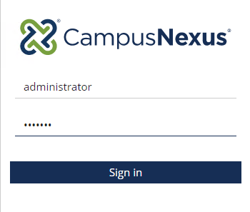

1. Select the ***Form Designer*** to start creating your form.

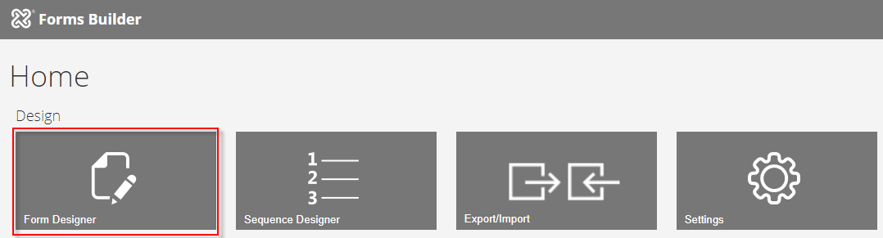

1. Select ***New.*** A ***1 Column*** panel is added to the ***Layout*** pane in the Designer.

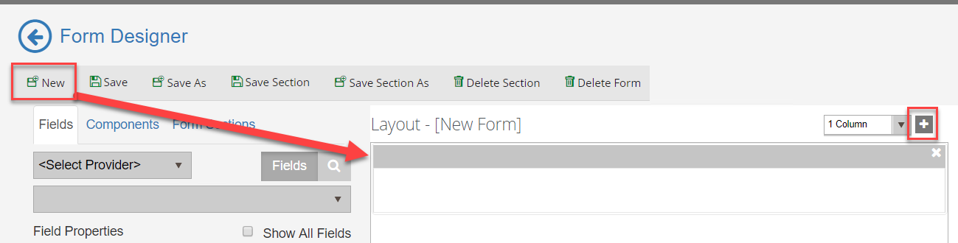

1. From the ***Components*** tab, drag two ***HTML*** components into the panel of the ***Layout*** pane.

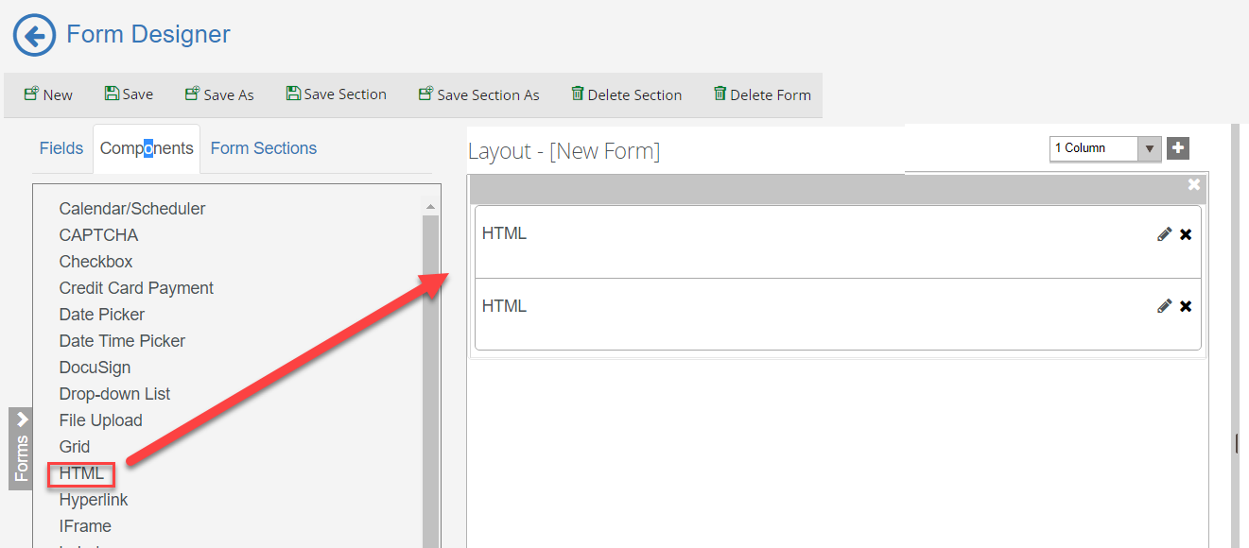

1. Enter the following for the first ***HTML*** component in the ***HTML*** property of the ***Control Property Settings*** pane:

***<h1>FERPA RELEASE FORM</h1>***

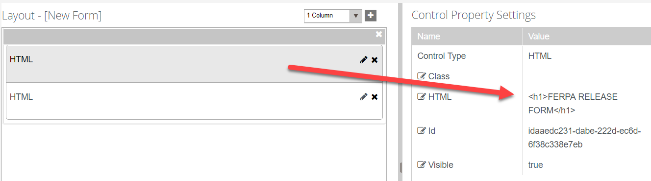

1. Enter the following for the second ***HTML*** component in the ***HTML*** property of the ***Control Property Settings*** pane:

***<b><i>The Family Educational Rights and Privacy Act of 1974, also known as FERPA and/or The Buckley Amendment of 1974, as amended, grants students and eligible parents certain rights and privacies regarding education records of students attending postsecondary institutions. By submitting this form, the student may consent to release his/her educational records and/or other information to a third-party for a defined purpose. A new form must be submitted for each request.</i></b>***

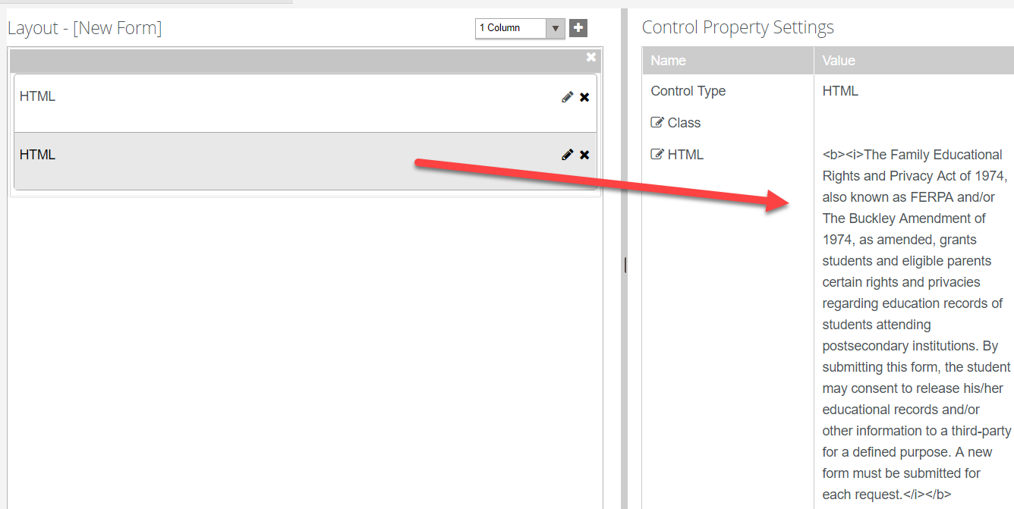

1. Click the ***+*** and select the column option to add a ***3 Column*** panel to the ***Layout*** pane.

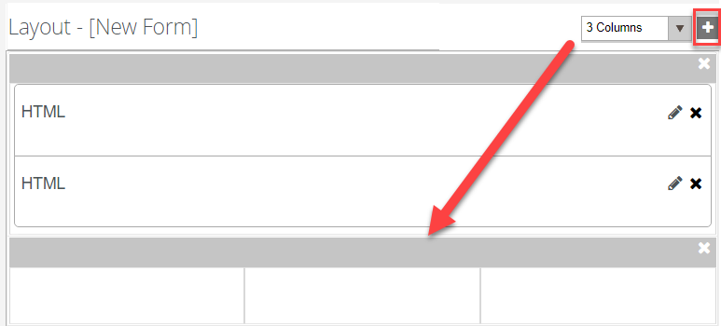

1. From the ***Components*** tab, drag three ***HTML*** components into the panel of the ***Layout*** pane.

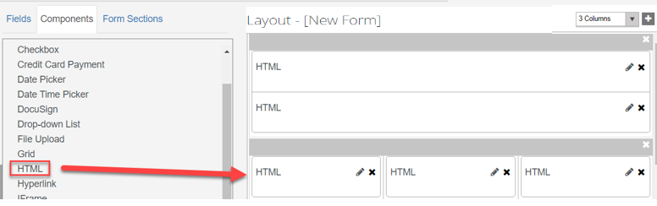

1. For the first ***HTML*** component, enter the following in the ***HTML*** property of the ***Control Property Settings*** pane:

***<b>Student Information:</b>***

***Note:*** The second and third ***HTML*** components are used as a place holder so we will not enter anything in the ***Control Property Settings*** pane for these components.

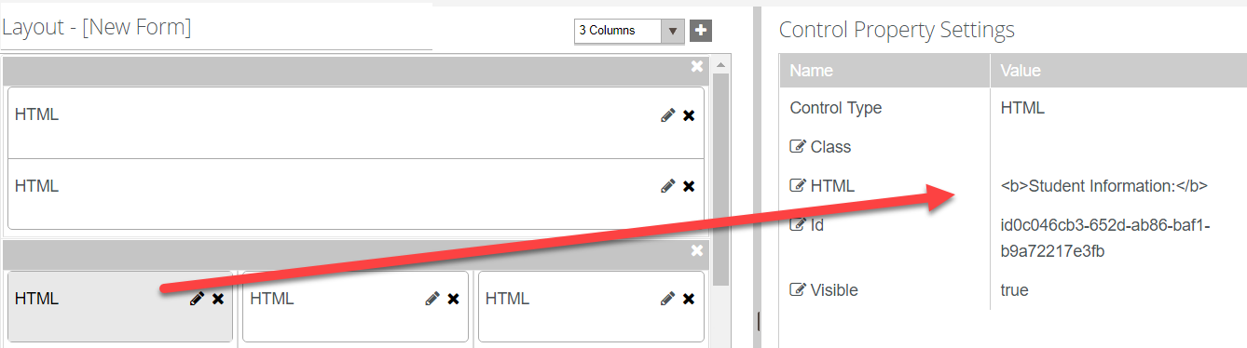

1. Select the ***Fields*** tab and under ***Student*** select the ***Student*** entity. Drag the following fields into the second panel below the ***HTML*** components as shown below:

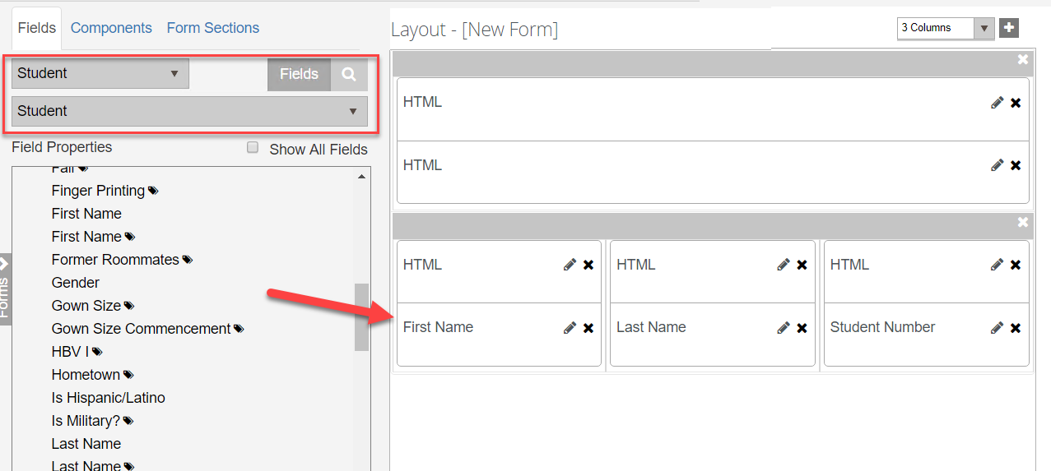

1. Make sure the ***Read-only*** property in the ***Control Property Settings*** pane is set to ***true*** for the ***First Name*** and ***Last Name*** fields.

 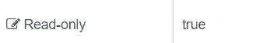

1. Make sure the ***Required*** property in the ***Control Property Settings*** pane is set to ***false*** for the ***First Name*** and ***Last Name*** fields.

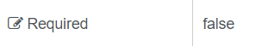

1. Click the ***+*** and select the column option to add a ***1 Column*** panel to the ***Layout*** pane.

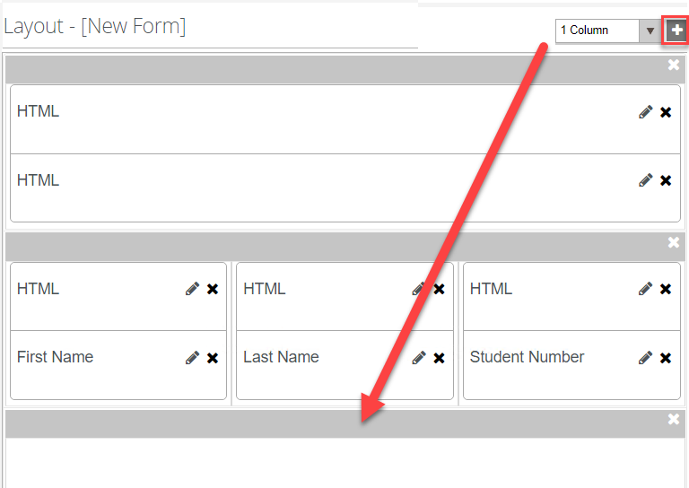

1. From the ***Components*** tab, drag an ***HTML*** component, two ***Checkbox*** components and another ***HTML*** component into the panel of the ***Layout*** pane.

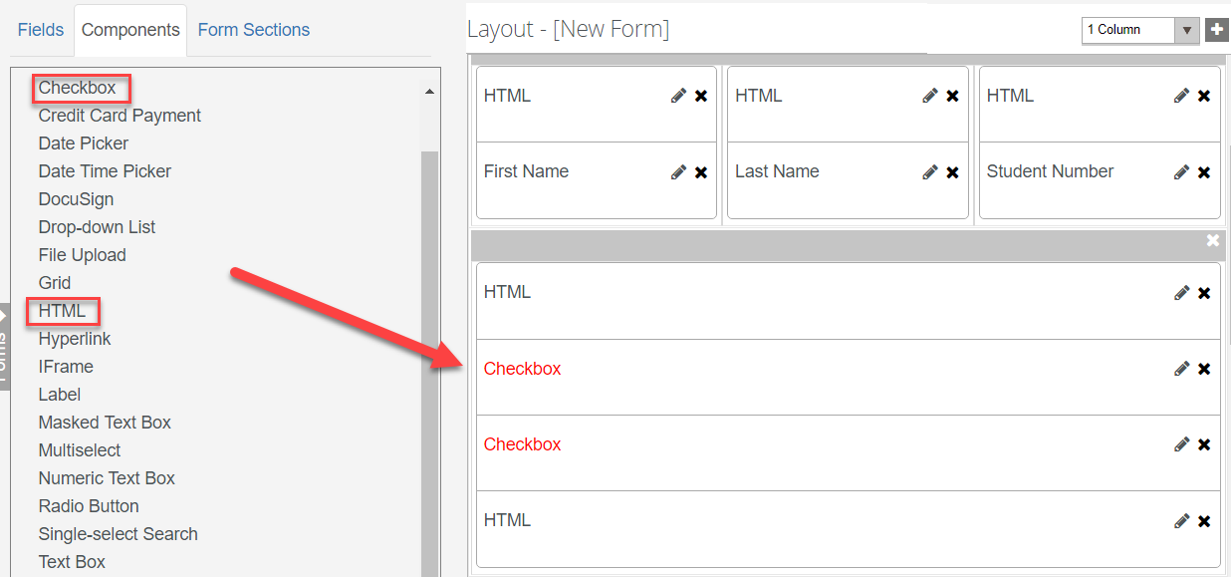

1. For the first ***HTML*** component, enter the following in the ***HTML*** property of the ***Control Property Settings*** pane:

***<b>Directory Information to Release:</b>***

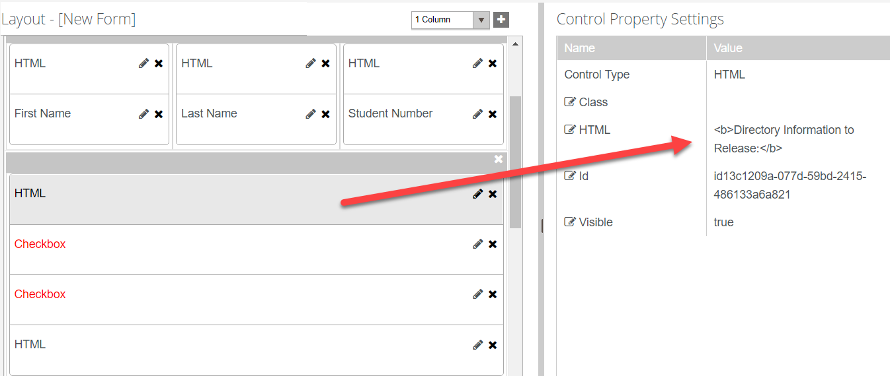

1. Update the following properties for the first ***Checkbox*** component as shown below:

* ***Label: I DO NOT authorize Campus University to disclose any personally identifiable information from my student records.***
* ***Model: vm.models.myAckNot***

**Note:** When we create our supporting Workflow, we will create an ***In/Out Argument*** of ***myAckNot.*** This will allow us to pass data to and from the field on the form.

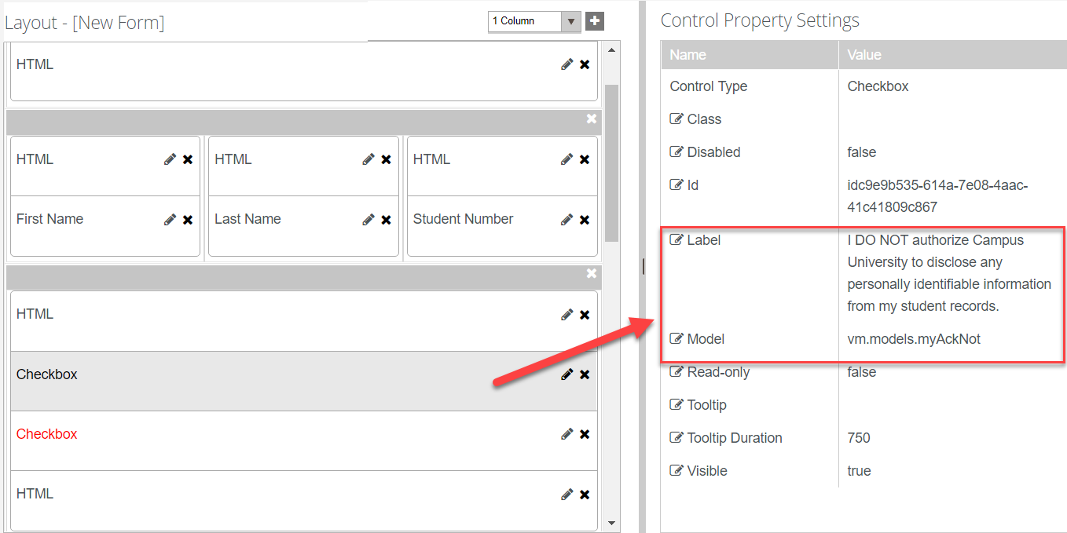

1. Update the following properties for the second ***Checkbox*** component as shown below:

* ***Label: I authorize Campus University to disclose all of the following personally identifiable information from my student records as listed below.***
* ***Model: vm.models.myAckTrue***

**Note:** When we create our supporting Workflow, we will create an ***In/Out Argument*** of ***myAckTrue.*** This will allow us to pass data to and from the field on the form.

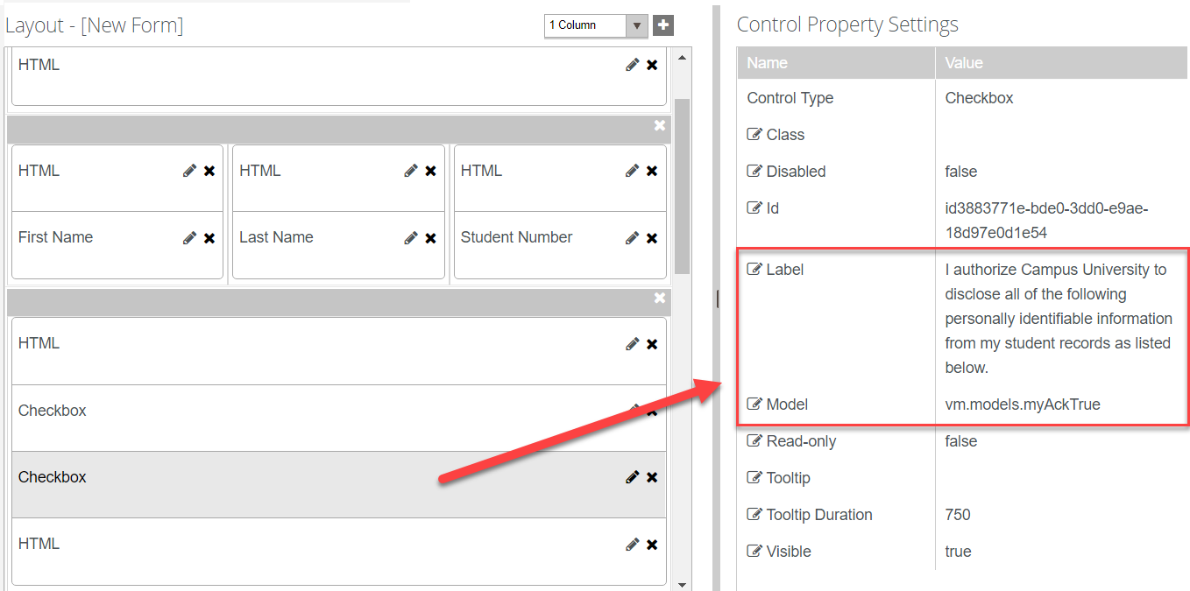

1. For the second ***HTML*** component, enter the following in the ***HTML*** property of the ***Control Property Settings*** pane:

***<ul style="list-style-type:square;">***

***<li>Student Name</li>***

***<li>Address</li>***

***<li>Telephone Number</li>***

***<li>E-mail Address</li>***

***<li>Photograph</li>***

***<li>Date of Birth</li>***

***<li>Place of Birth</li>***

***<li>Campus</li>***

***<li>Major Field of Study</li>***

***<li>Dates of Attendance</li>***

***<li>Grade Level</li>***

***<li>Enrollment Status</li>***

***<li>Participation in Activities</li>***

***<li>Degrees</li>***

***<li>Honors and Awards</li>***

***<li>Recent Institution Attended</li>***

***</ul>***

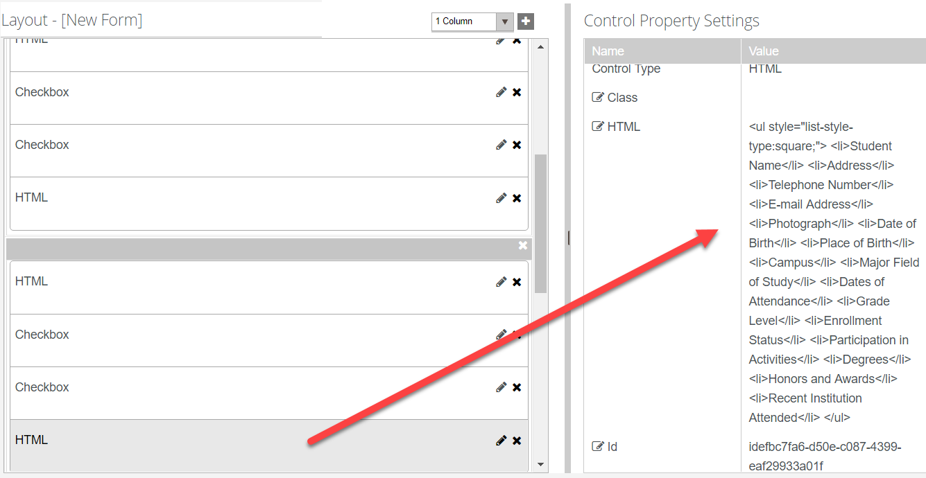

1. Click the ***+*** and select the column option to add a ***3 Column*** panel to the ***Layout*** pane.

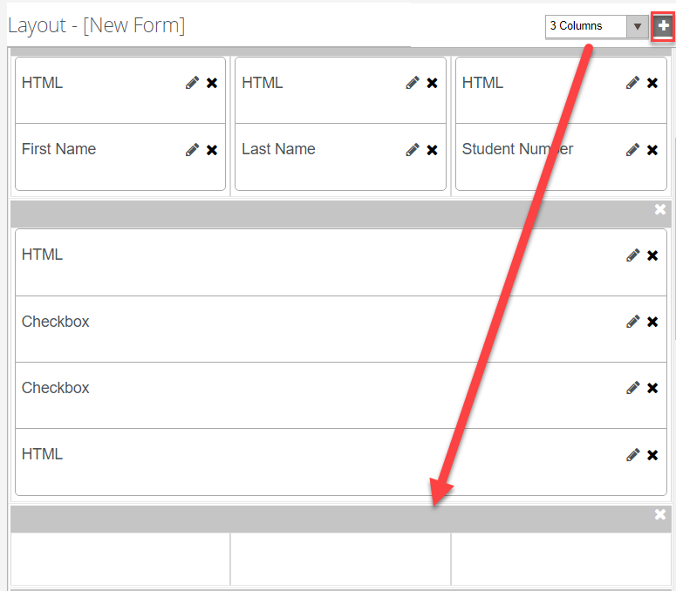

1. From the ***Components*** tab, drag three ***HTML*** components into the panel of the ***Layout*** pane.

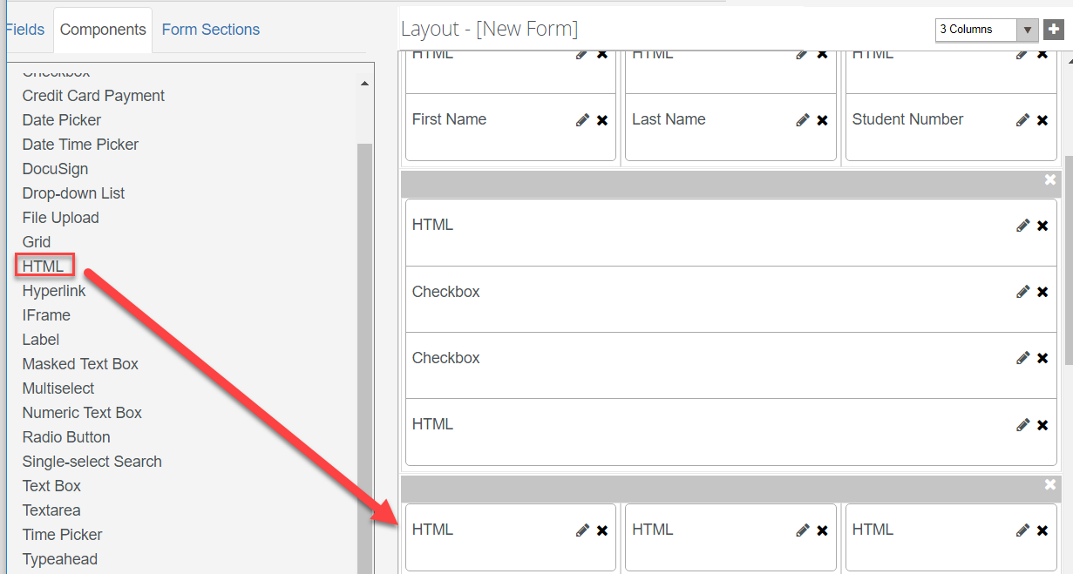

1. For the first ***HTML*** component, enter the following in the ***HTML*** property of the ***Control Property Settings*** pane:

***<b>Education Information to Release:</b><br><br><b><i>I authorize Campus University to release the following types of Education Information.</i></b>***

***Note:*** The second and third ***HTML*** components are used as a place holder so we will not enter anything in the ***Control Property Settings*** pane for these components.

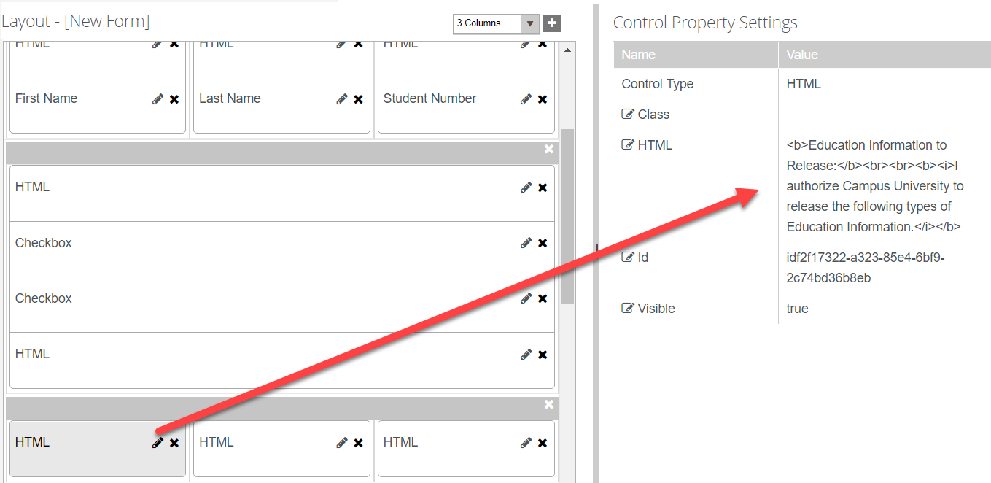

1. From the ***Components*** tab, drag multiple ***Checkbox*** and ***HTML*** components into the panel of the ***Layout*** pane as shown below.

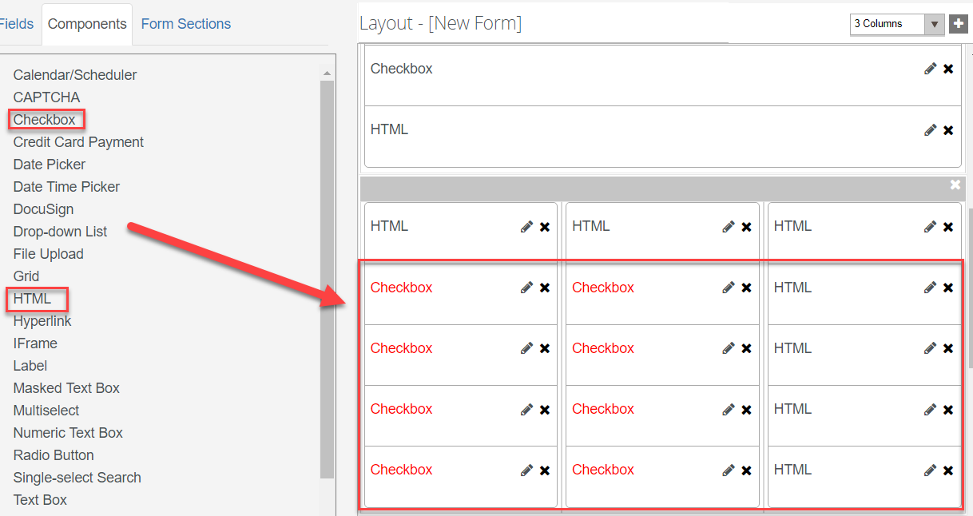

1. Complete the properties for each ***Checkbox*** component as shown below:

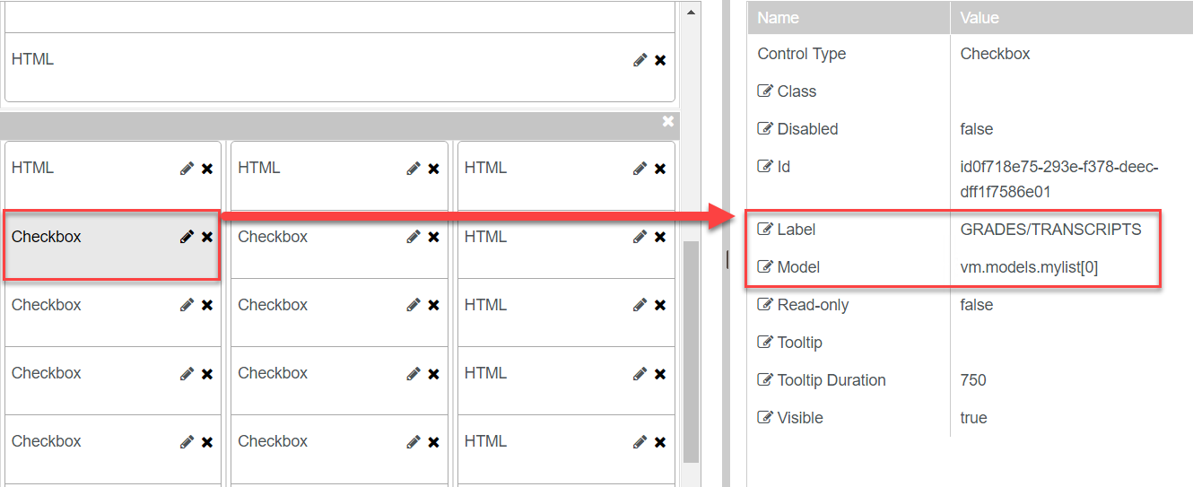

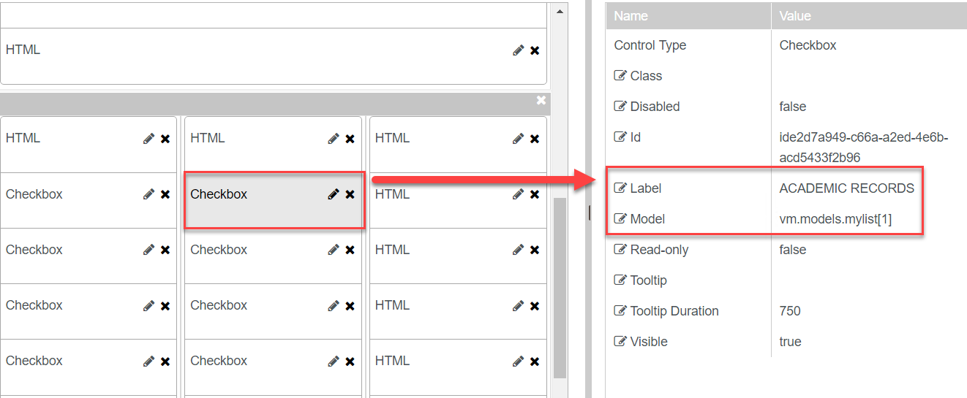

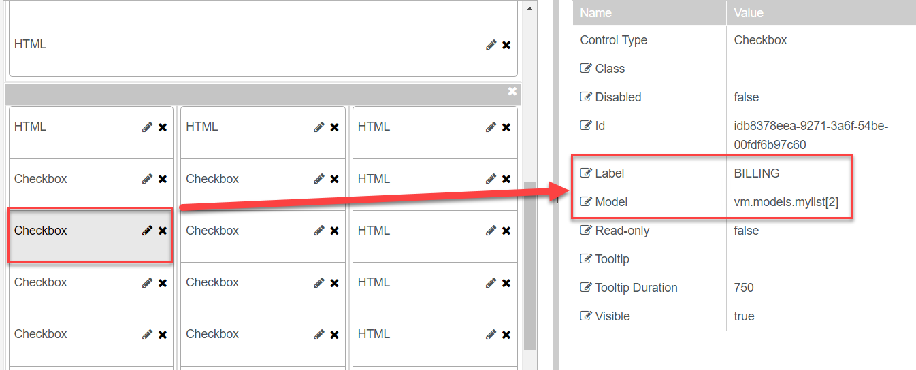

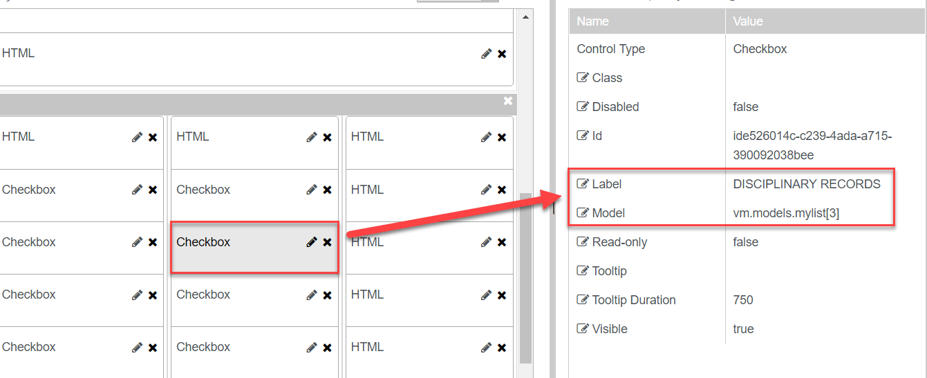

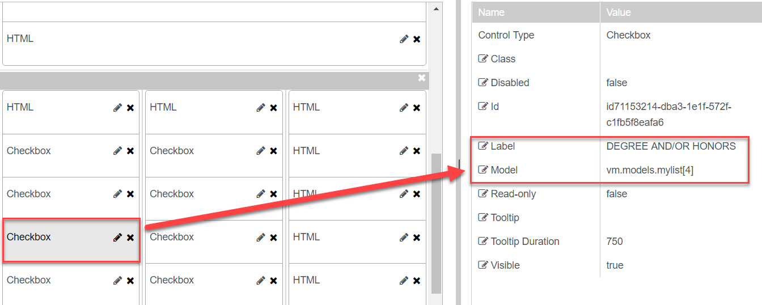

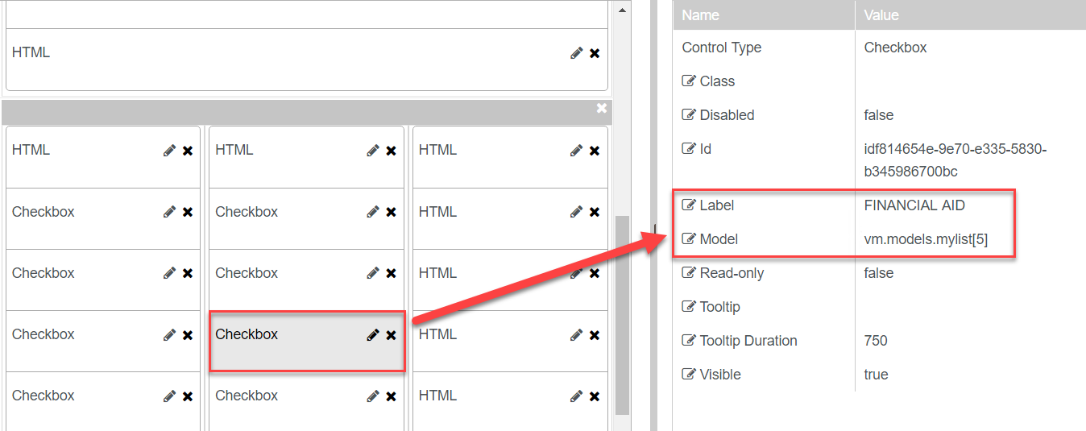

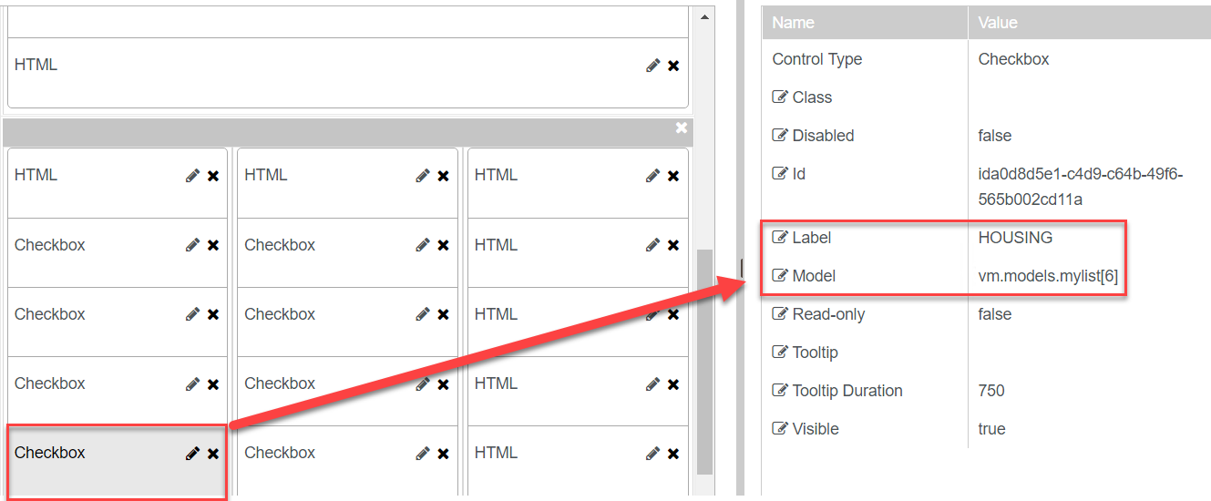

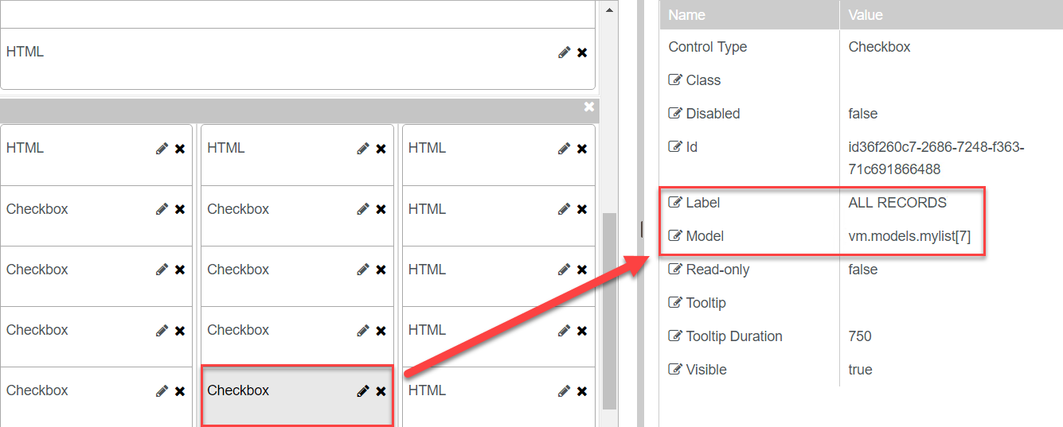

1. The ***HTML*** components are used as placeholders so we do not need to update any properties for these components.

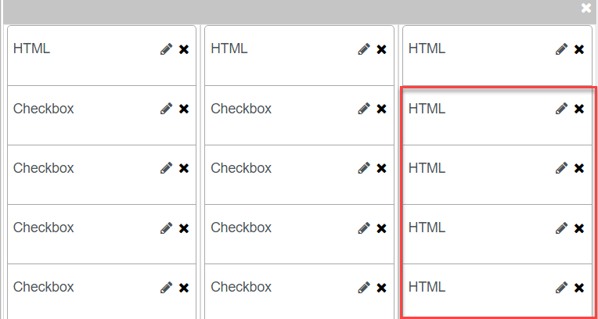

1. From the ***Components*** tab, drag three ***HTML*** components into the panel of the ***Layout*** pane.

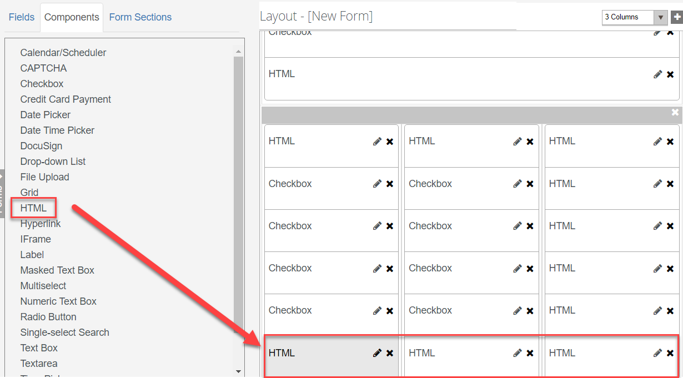

1. For the first ***HTML*** component, enter the following in the ***HTML*** property of the ***Control Property Settings*** pane:

***<b>Person Authorized:</b><br><br><b><i>This information may be released to the person listed below.</i></b>***

***Note:*** The second and third ***HTML*** components are used as a place holder so we will not enter anything in the ***Control Property Settings*** pane for these components.

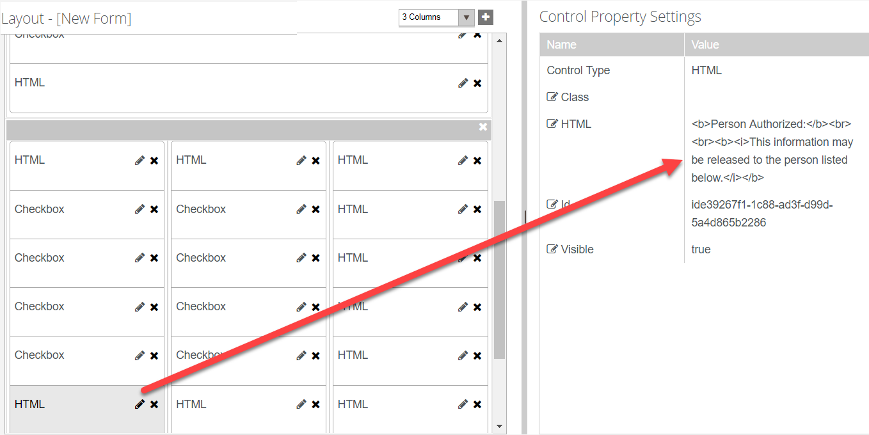

1. Select to ***Show All Fields*** on the ***Fields*** tab. This will load all entities from the data model.

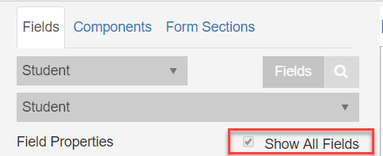

1. Once the entities load, select ***Student Relationship Address*** from the drop-down.

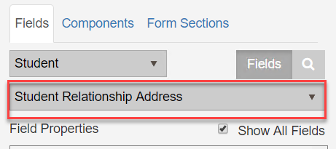

1. Drag the following fields into the panel of the ***Layout*** pane.

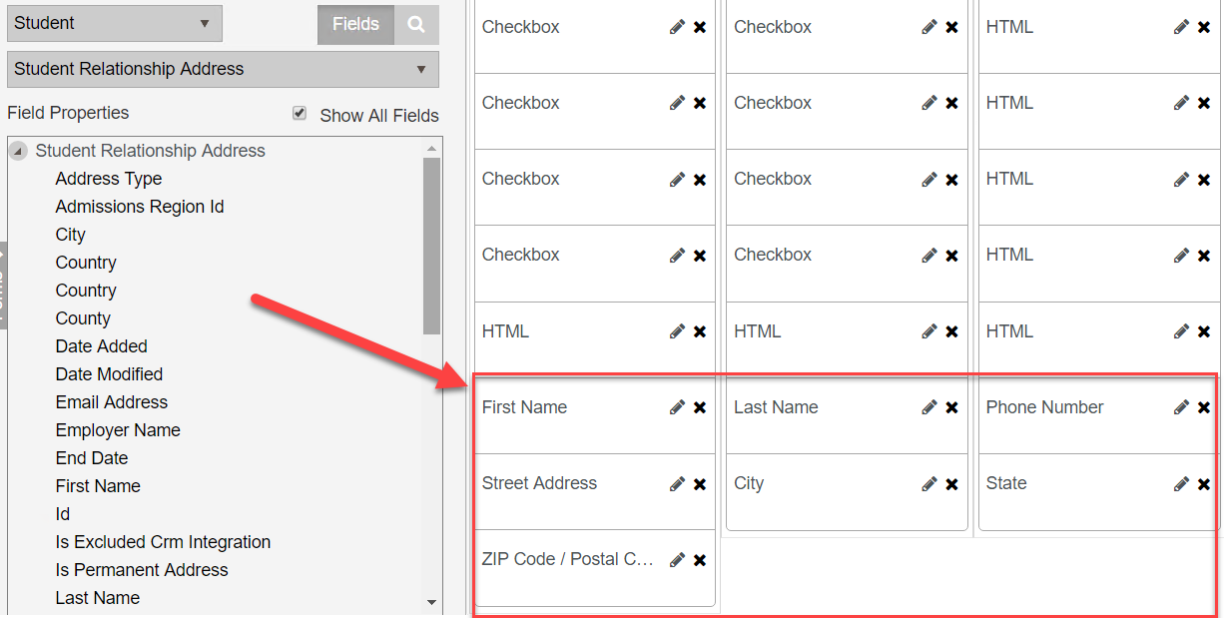

1. Make sure the ***Required*** property in the ***Control Property Settings*** pane is set to ***true*** for the all of the fields.



1. Drag a ***Masked Text Box*** from the components tab above the ***Phone Number*** field. Update the properties for the ***Masked Text Box*** in the ***Control Property Settings*** pane as shown below.

* ***Format: (###)###-####***
* ***Label: Phone Number***
* ***Model: vm.models.studentRelationshipAddressEntity.PhoneNumber***

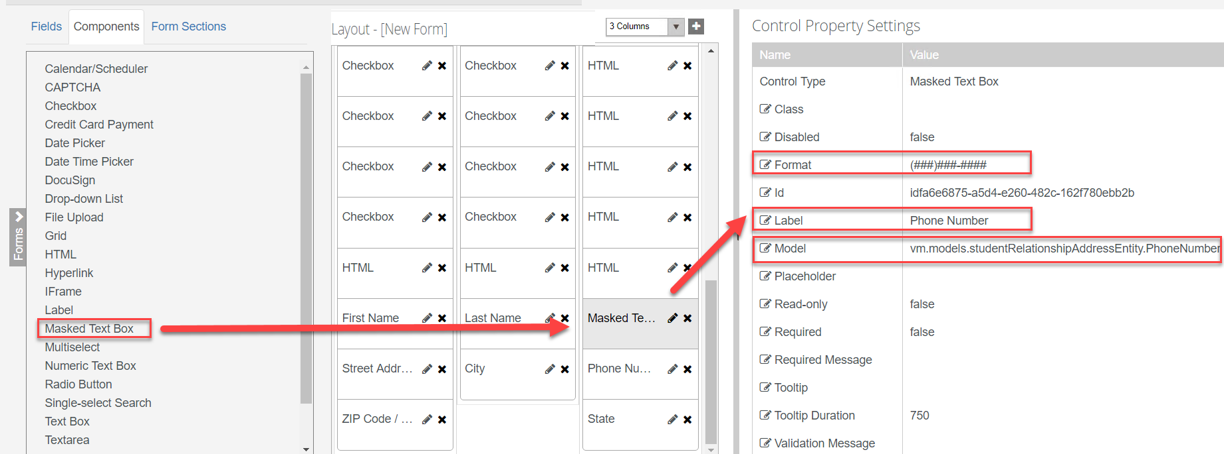

1. ***Delete*** the ***Phone Number*** field from the form.

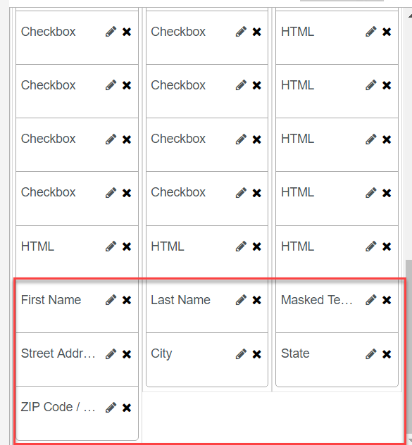

1. ***Save*** and name your Form with your initials at the end as shown below.

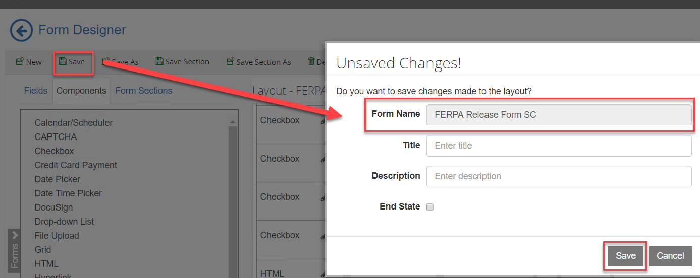

1. On the top left bar, click on the ***arrow*** to navigate out of Form Designer.

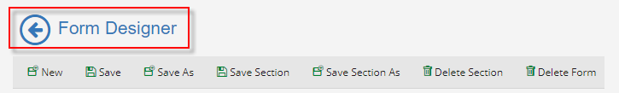

1. Select ***Sequence Designer*.**

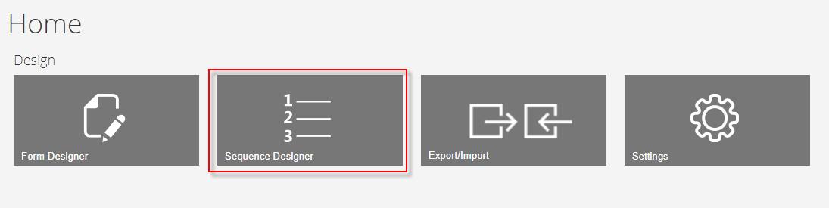

1. Select ***New*** and a new panel will be created for you to drag your forms into for creating your sequence.

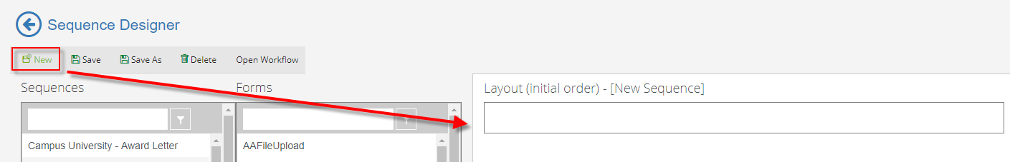

1. From the ***Forms*** column drag your form in the ***New Sequence*** panel in the ***Layout*** pane as shown below.

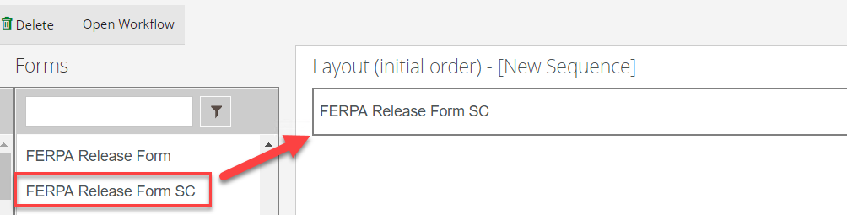

1. In the ***Properties*** pane, update the properties as shown below and select ***Save.***

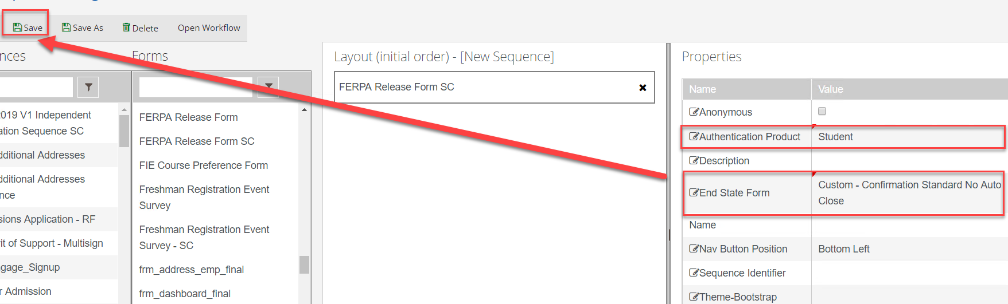

1. ***Save*** the Sequence with Your initials at the end as shown below.

**NOTE: DO NOT PUT EXTRA SPACES OR DASHES IN THE SEQUENCE NAME.**

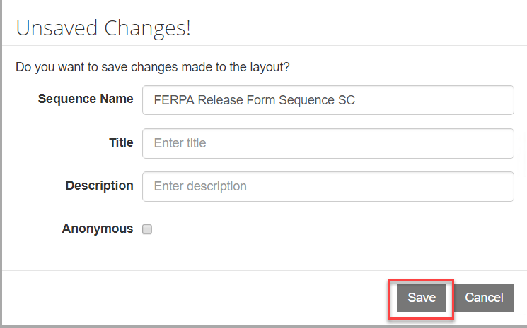

1. Once saved, select the ***Sequence*** in the ***Sequence pane*** and select ***Open Workflow*.**

**Note:** This will open Workflow Composer and create the State Machine Workflow shell for us to start creating our supporting workflow for the form. You can also open up the Workflow directly from Workflow Composer.

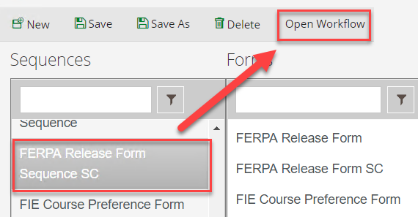

1. Rename the ***StateMachine******Flow*** to ***StateMachine-FERPA Release of Information*.** You can do this by double-clicking on the title at the top.

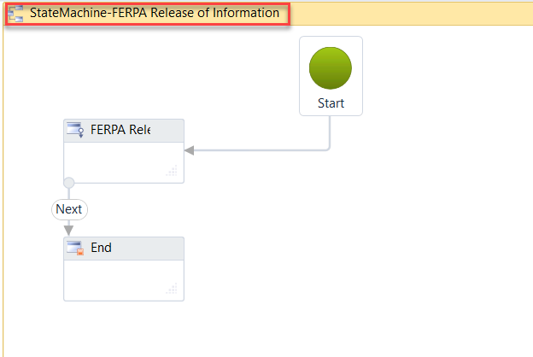

1. Select the second sequence in the state machine flow to give it the focus and hit the right arrow on your keyboard to move the sequence to the right. This helps to organize our state machine flow to better navigate.

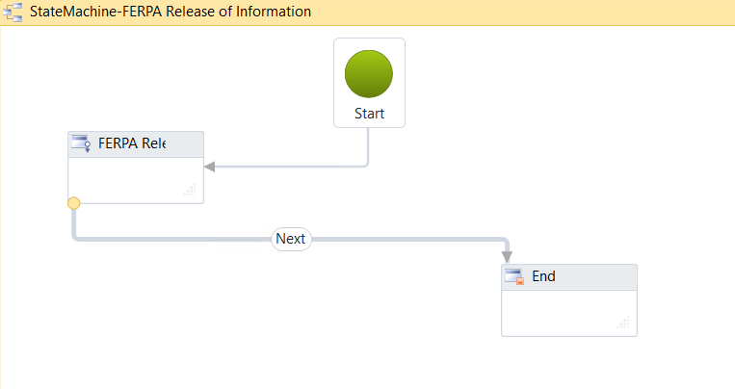

1. Create the following ***Arguments*** as shown below. These are the model values that we populated on our form fields for our components.

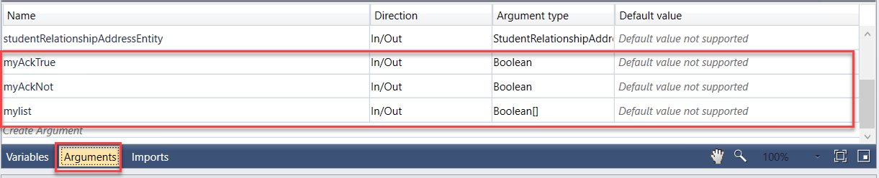

**Note:** The name has to match the exact model name used for the field on the form. For the ***mylist*** argument, for ***Argument type*** you will need to select the ***Array of [T] then select Boolean.***

1. ***Double-click*** the first sequence in the state machine flow. This will allow you to go to the first transition in your form. We can specify in this section what we want to occur when the student enters the form.

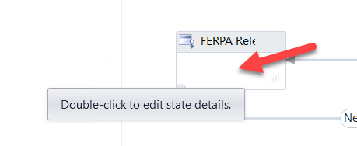

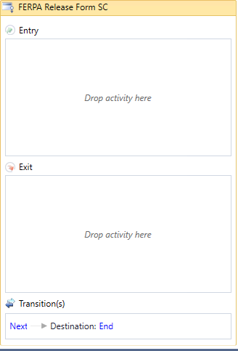

1. We want to organize our Workflow by adding containers to specify what we are doing in each section. This will allow us to better understand and visualize the logic occurring within the Workflow.
2. Drag a ***Sequence*** activity onto the designer in the ***Entry*** section of the activity. Rename the sequence to ***Find Student*.**

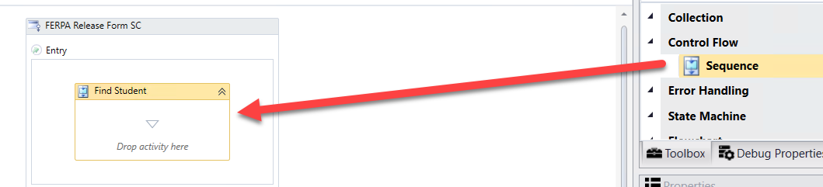

1. The first thing that we want to do is find the student that is completing the form in order to initialize the form and display values back to our FERPA Release Formas needed. We will then continue finding and assigning other values that we will need for the form as the student moves through the sequence.

1. Drag the ***LookupUser*** activity onto the designer into the ***Find Student Sequence***. We use this activity to find the student completing the form.

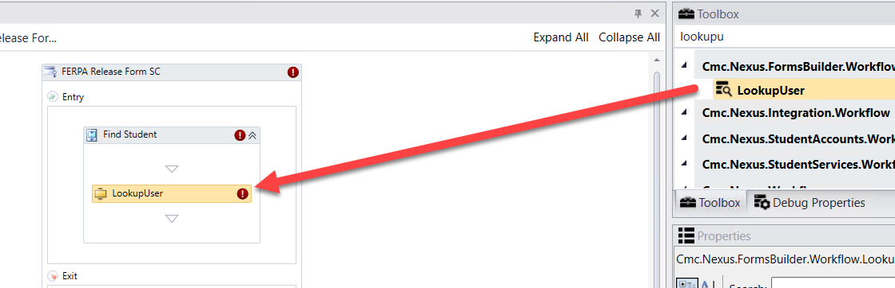

1. Create a variable:

* ***Name: studentid***
* ***Variable type: Int32***
* ***Scope: StateMachine-FERPA Release of Information***

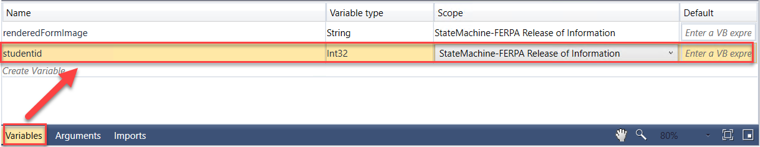

1. Complete the properties for the ***LookupUser*** activity as shown below:

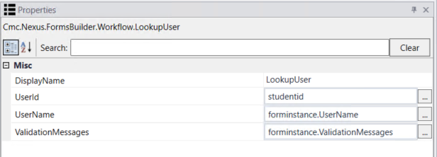

1. We then want to get the data from the ***studentEntity*** so we can display it back to our form. We use the ***GetEntity*** activity since we already have the student in the ***CampusNexus Student*** database.
2. Drag the ***GetEntity*** activity onto the designer below the ***LookupUser*** activity.

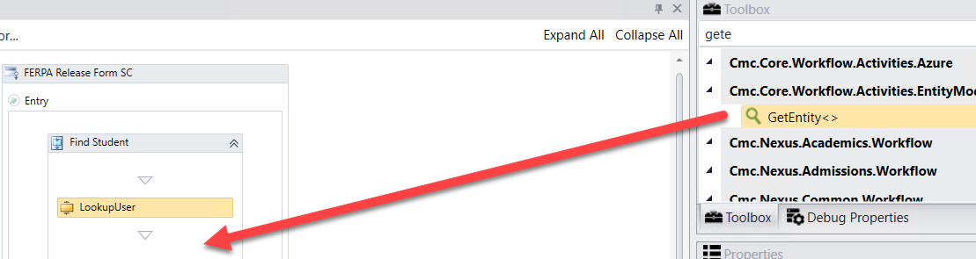

1. When the box pops up, ***Browse for Types*.**

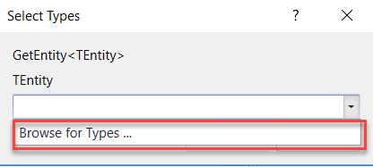

1. Navigate to: ***Cmc.Nexus.Common.Contracts>Cmc.Nexus.Common.Entities>StudentEntity and click OK***.

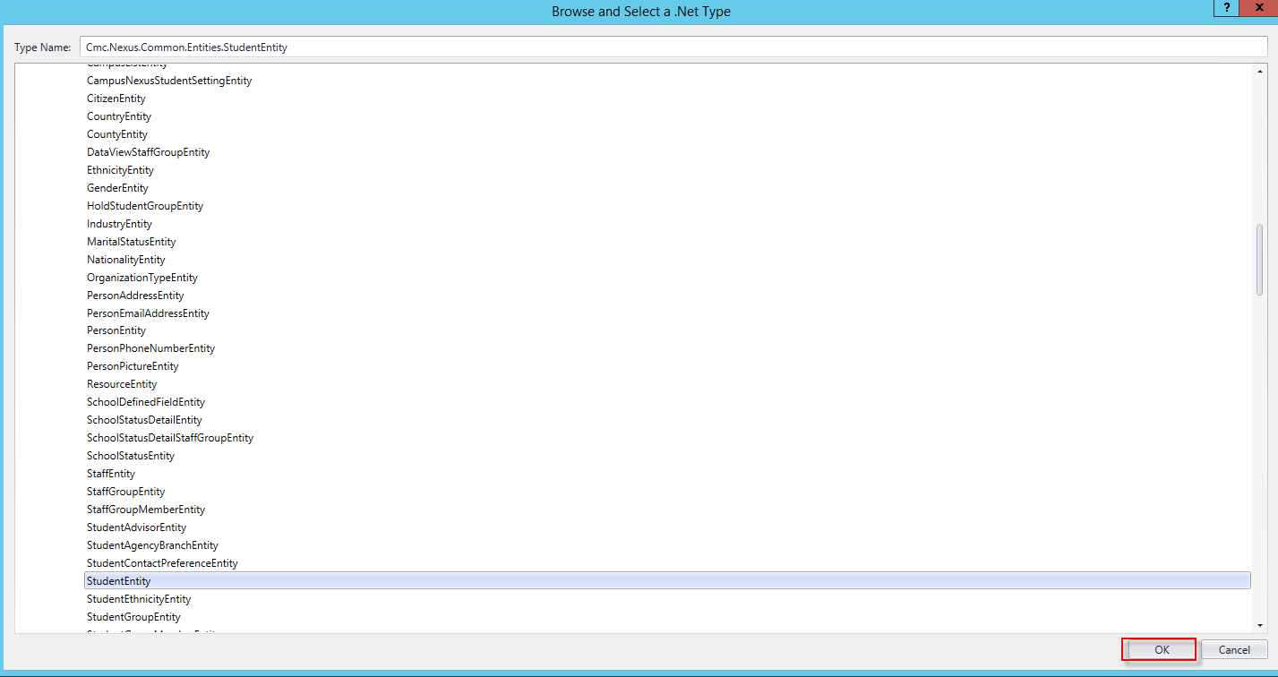

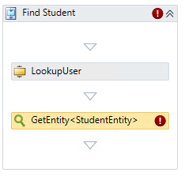

1. Specify the properties in the ***Properties pane*** for the ***GetEntity*** activity.

**Note:** The ***EntityId***is your variable of ***studentid*** and the Result is the ***studentEntity***.

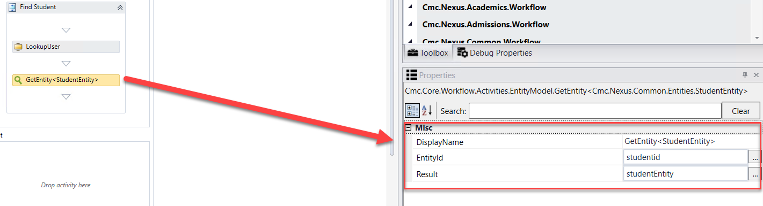

1. Drag two ***Assign*** activities onto the Designer in the ***Find Student Sequence*** activity below the ***GetEntity*** activity. Update the properties as follows:

* ***Display Name***:  ***Assign Data Block Indicator***; ***studentEntity.DataBlockIndicator=True***
* ***Display Name: Assign list to array;***

***mylist=New Boolean() {false, false, false, false, false, false, false, false}***

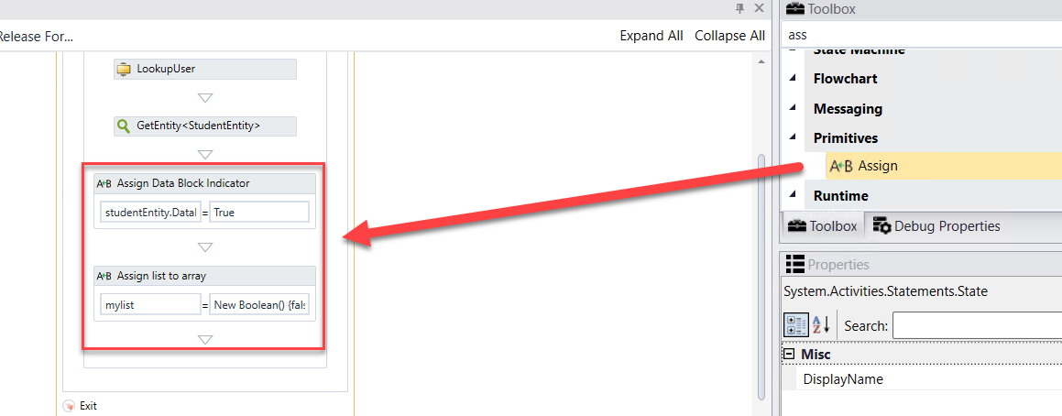

1. In our FERPA Release Form Sequence, we will be adding an address for the student in the ***Addresses Folder*** in ***CampusNexus Student*** for FERPA. We need to create the entity so once we collect the data from the student on the form we can save the values back to the database.
2. Drag a ***CreateEntity*** activity onto the designer below the ***Assign list to array Assign*** activity

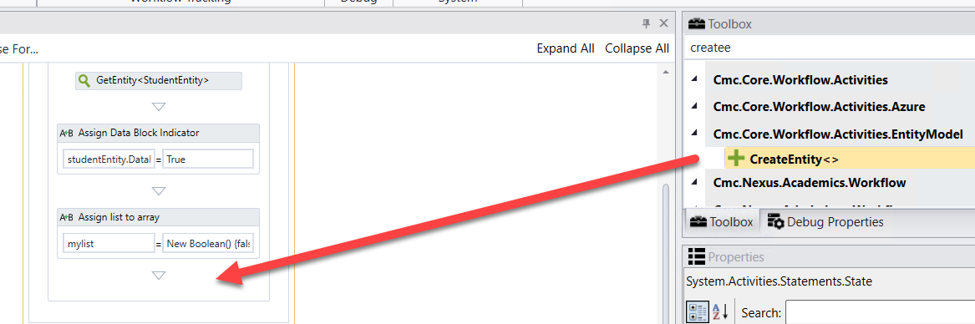

1. When the box pops up, ***Browse for Types*.**

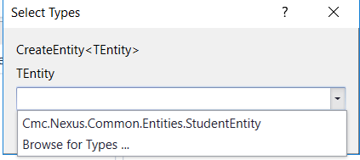

1. Navigate to: ***Cmc.Nexus.Common.Contracts>Cmc.Nexus.Common.Entities>StudentRelationshipAddressEntity and click OK***.

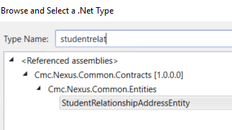

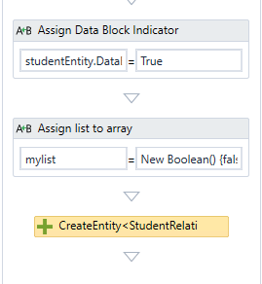

1. Specify the properties in the ***Properties pane*** for the ***CreateEntity*** activity as shown below:

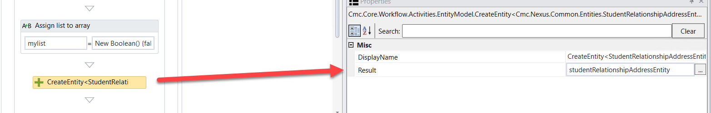

1. Click ***Next*** at the bottom of the form to enter the next transition of your ***FERPA Release of Information Form Sequence***.

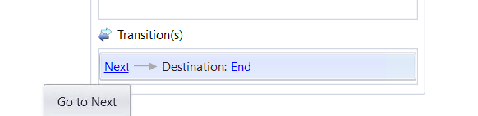

1. Rename the ***WaitForFormBookmark*** activity and the Next button transition text to ***Submit***. Update the ***Condition as shown below.***

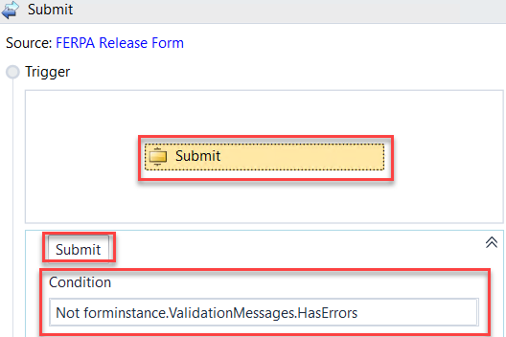

1. We want to organize our Workflow by adding containers to specify what we are doing in each section. This will allow us to better understand and visualize the logic occurring within the Workflow.
2. Drag three ***Sequence*** activities onto the designer below the ***Submit WaitForFormBookmark*** activity. This will also create a ***Sequence*** activity automatically around all of the activities.

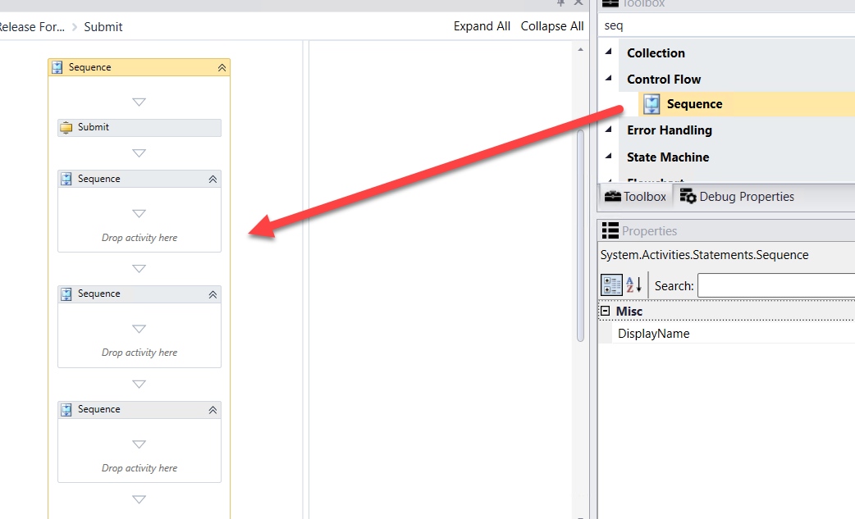

1. Rename each ***Sequence*** activity as shown below.

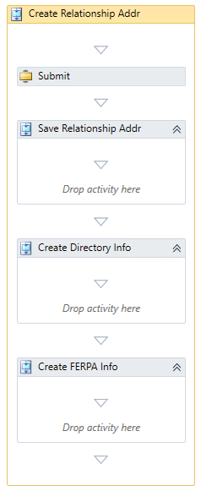

1. Drag two ***Assign*** activities onto the Designer in the ***Save Relationship Addr Sequence*** activity. Update the properties as follows:

* ***Display Name***:  ***Assign StudentID***; ***studentRelationshipAddressEntity.StudentId=studentEntity.Id***
* ***Display Name: Assign Address Type;***

***studentRelationshipAddressEntity.AddressTypeId=27***

**Note:** The AddressTypeId of 27 is the Id from the database for the FERPA address type.

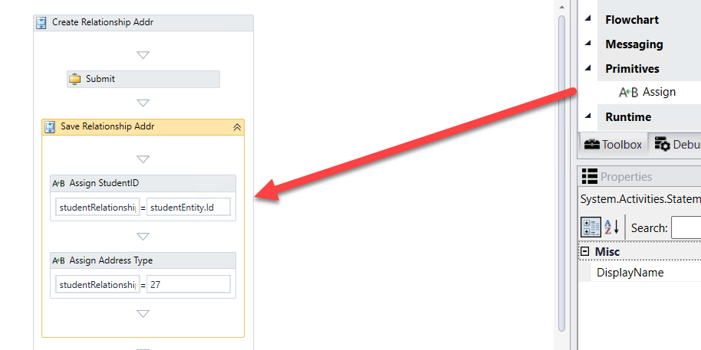

1. We now want to save the ***StudentRelationshipAddressEntity i***nformation. To save the data, drag a ***SaveEntity*** below the ***Assign Address Type Assign*** activity.

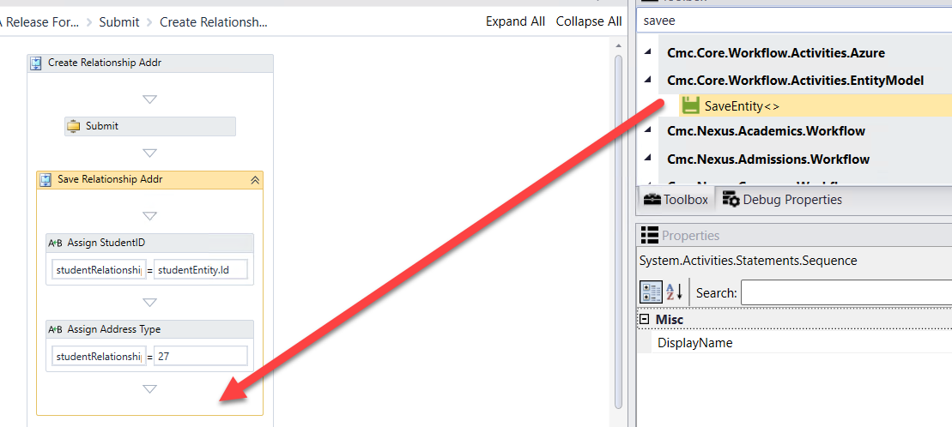

1. When the box pops up, ***Browse for Types*.**



1. Navigate to: ***Cmc.Nexus.Common.Contracts>Cmc.Nexus.Common.Entities>StudentRelationshipAddresEntity and click OK.***

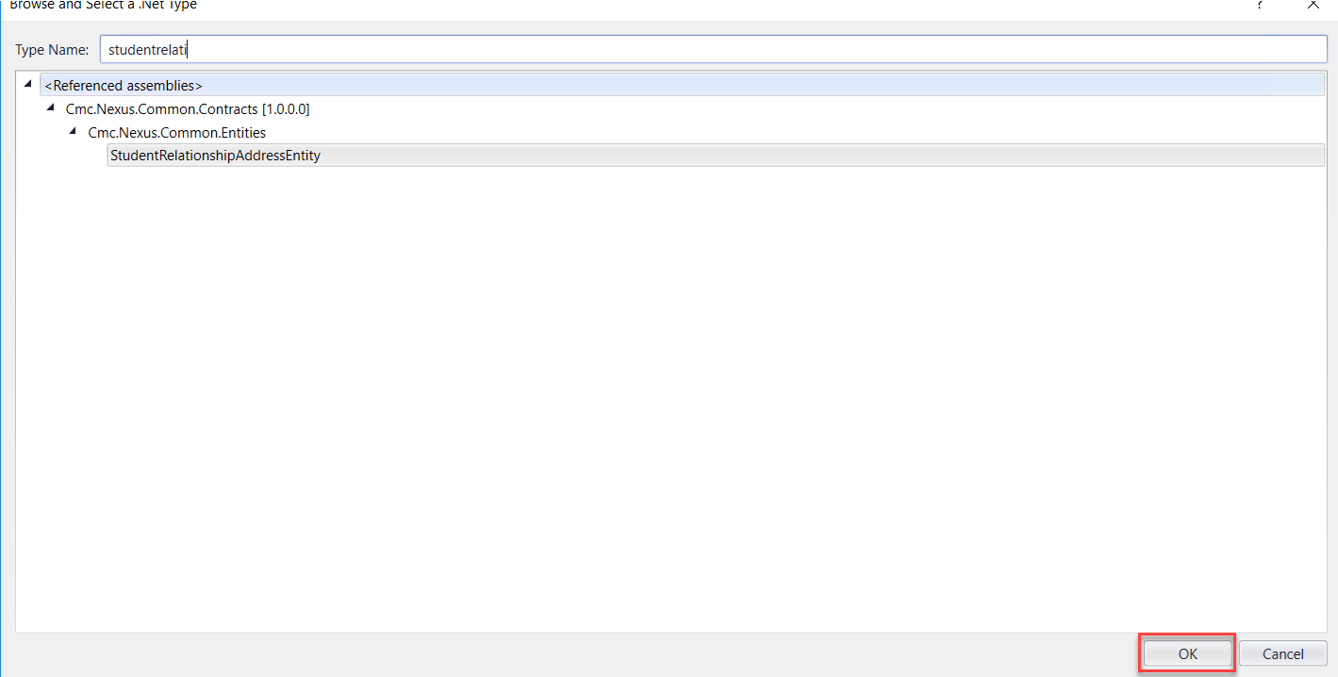

1. Specify the properties in the ***Properties pane*** for the ***SaveEntity*** activity.

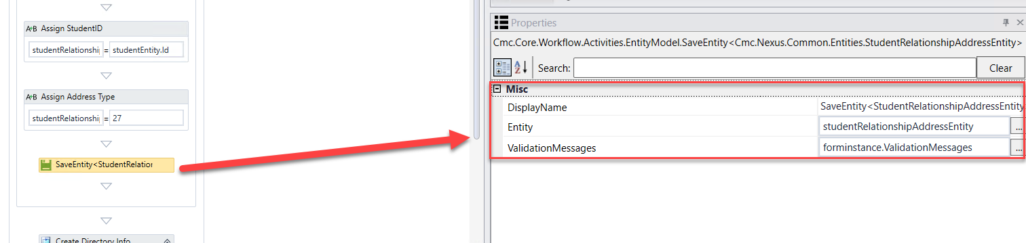

1. We now want to save the ***StudentEntity i***nformation. To save the data, drag a ***SaveEntity*** below the ***SaveEntity StudentRelationshipAddressEntity*** activity.

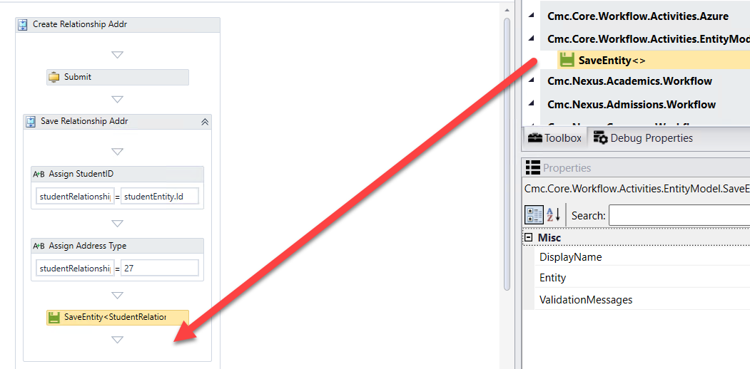

1. When the box pops up, ***Browse for Types*.**



1. Navigate to: ***Cmc.Nexus.Common.Contracts>Cmc.Nexus.Common.Entities>StudentEntity and click OK.***

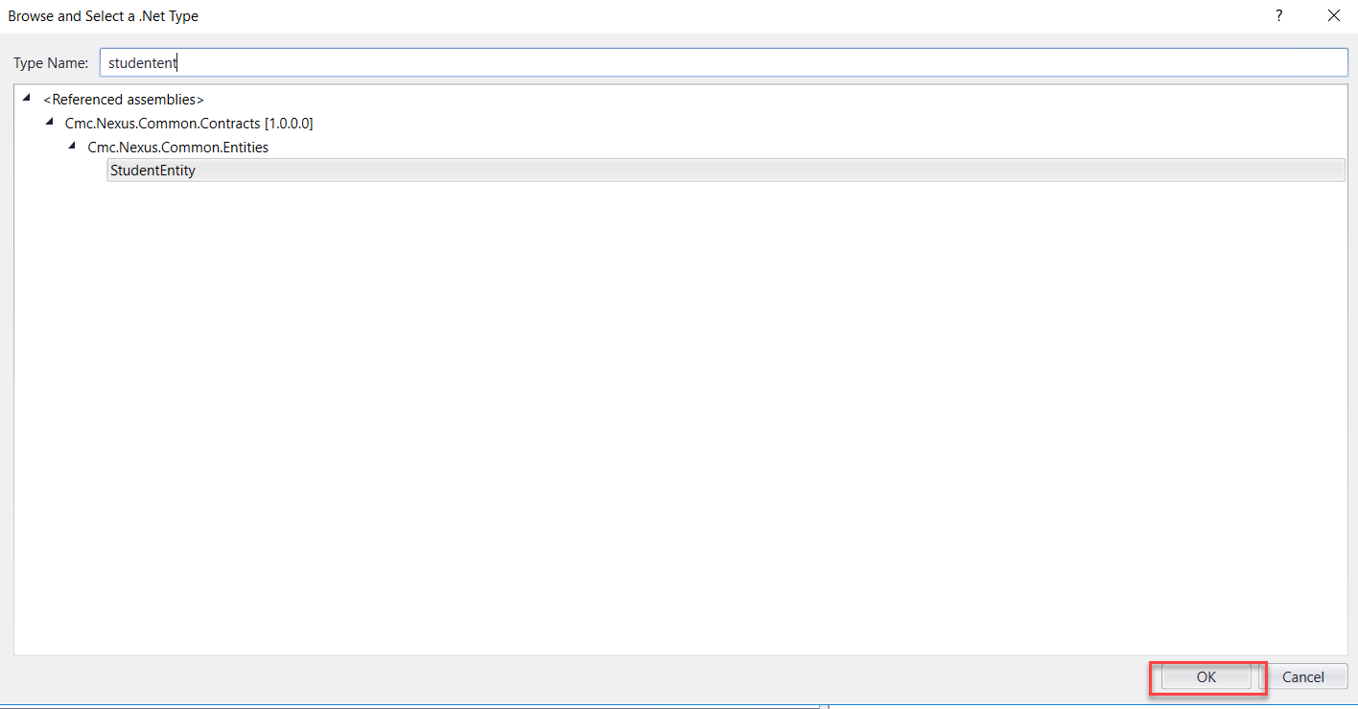

1. Specify the properties in the ***Properties pane*** for the ***SaveEntity*** activity.

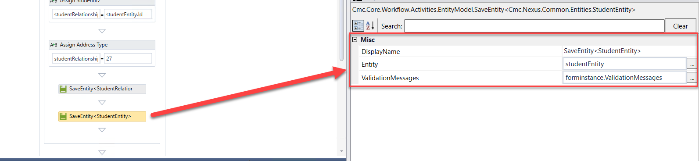

1. Drag an ***If*** activity into the ***Create Directory Info Sequence*** activity.

* Rename the activity to: ***If value to share is true***
* Condition: ***myAckTrue=True***

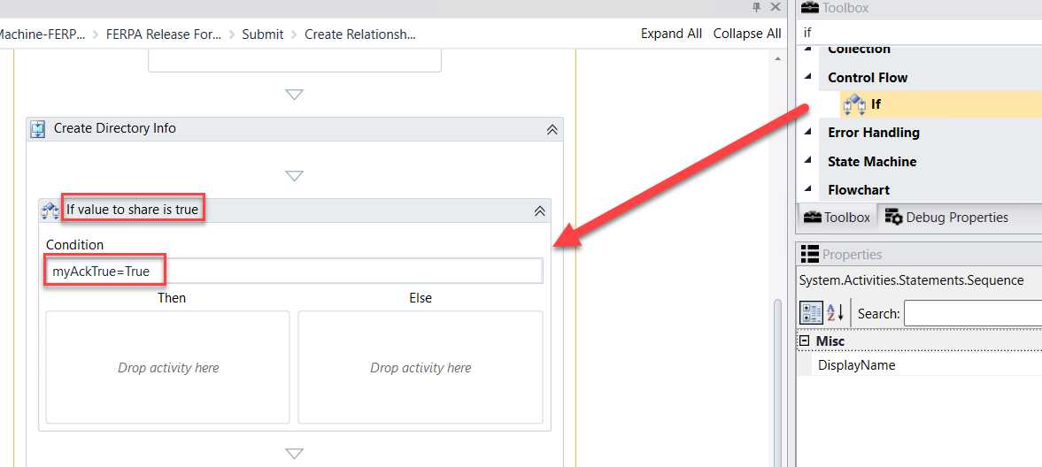

1. Drag a ***Sequence*** activity into the ***Then*** portion of the ***If*** activity. Rename the activity to: ***Mark field to share***

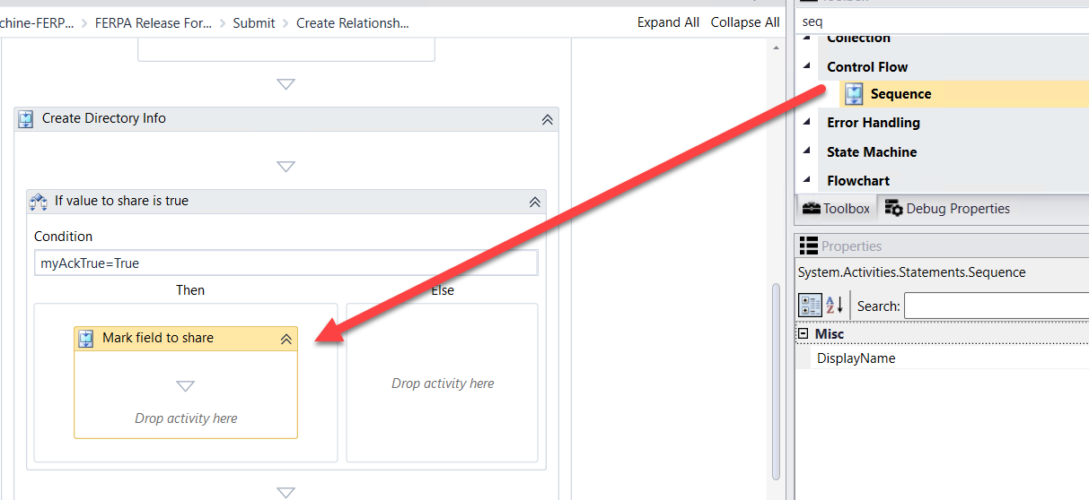

1. Create the following ***variables***:

* ***Name: StudentRelationship; Type: Cmc.Nexus.Crm.Contracts>Cmc.Nexus.Crm.Entities>FerpaStudentRelationshipEntity; Scope: StateMachine-FERPA Release for Information***
* ***Name: AcademicRelease; Type: Cmc.Nexus.Crm.Contracts>Cmc.Nexus.Crm.Entities>FerpaStudentReleaseAcademicFieldEntity; Scope: StateMachine-FERPA Release for Information***
* ***Name: DirectoryShare; Type: Cmc.Nexus.Crm.Contracts>Cmc.Nexus.Crm.Entities>FerpaStudentDirectoryFieldEntity; Scope: StateMachine-FERPA Release for Information***
* ***Name: count; Type: Int32; Scope: StateMachine-FERPA Release for Information***

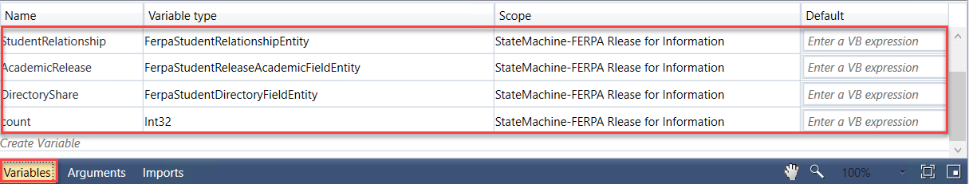

1. Drag an ***Assign*** activity into the ***Mark field to share Sequence*** activity. Complete the activity as follows:

* Rename the activity: ***Assign Initial Count***
* ***count=1***

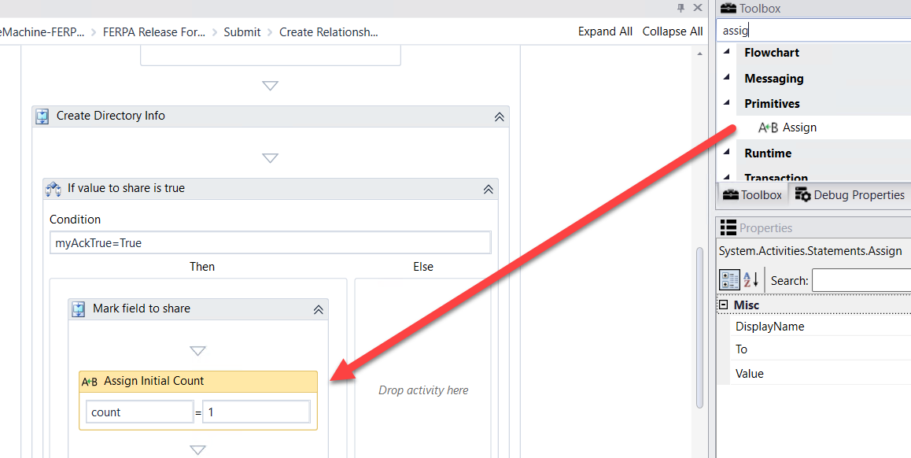

1. Drag a ***DoWhile*** activity below the ***Assign Initial Count Assign*** activity. For the ***Condition*** enter the following: ***count<17***

**Note: There are 16 directory Id's in the table. We are going to loop through and add each one as selected/unselected for the student relationship table.**

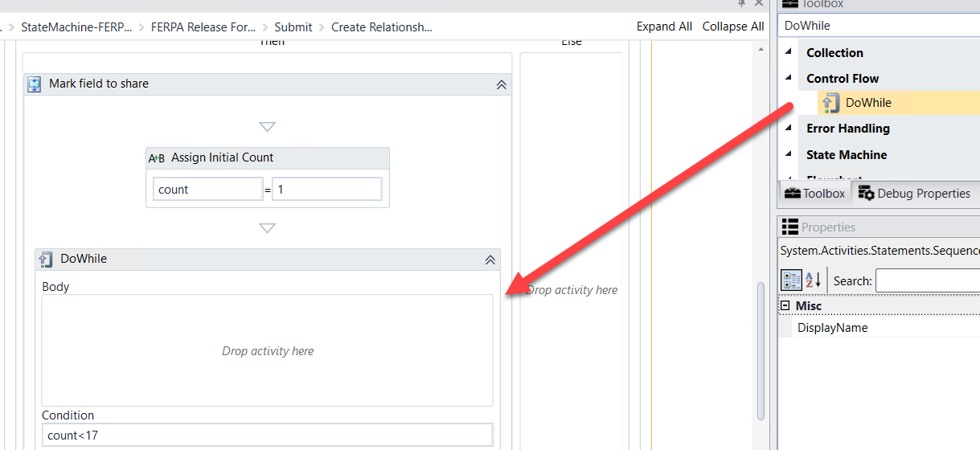

1. Drag a ***Sequence*** activity into the ***Body*** of the ***DoWhile*** activity. Rename the activity to:

***Create Directory Info***

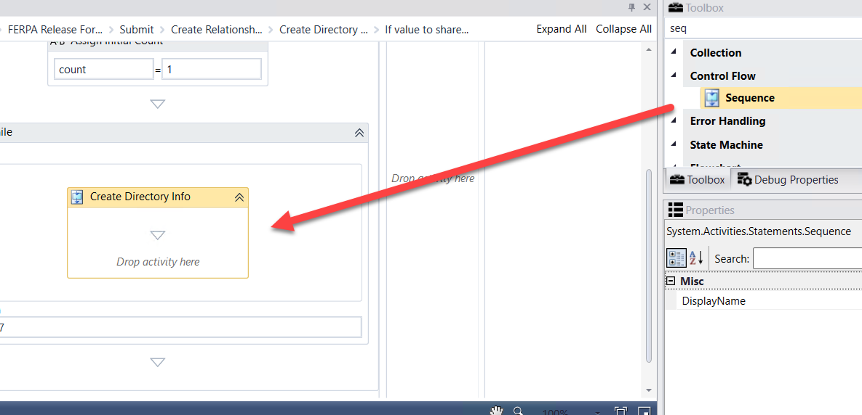

1. Drag a ***CreateEntity*** activity in the ***Create Directory Info Sequence*** activity.

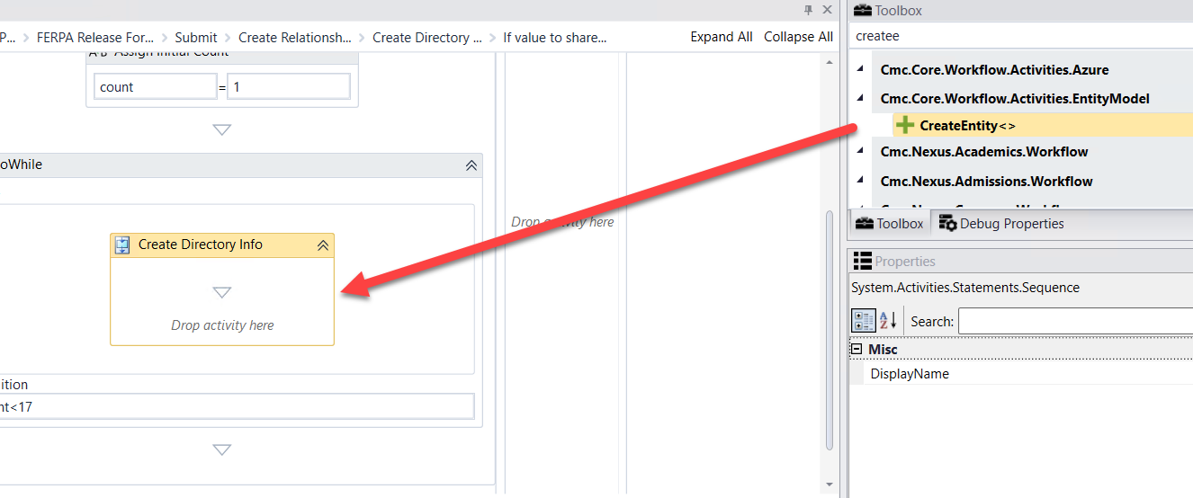

1. ***Browse for Type: Cmc.Nexus.Crm.Contracts>Cmc.Nexus.Crm.Entities>FerpaStudentDirectoryFieldEntity and Click OK***

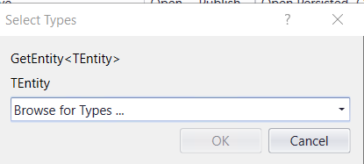

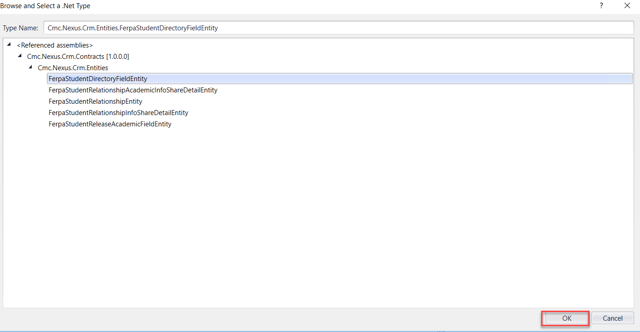

1. Complete the properties as shown below.

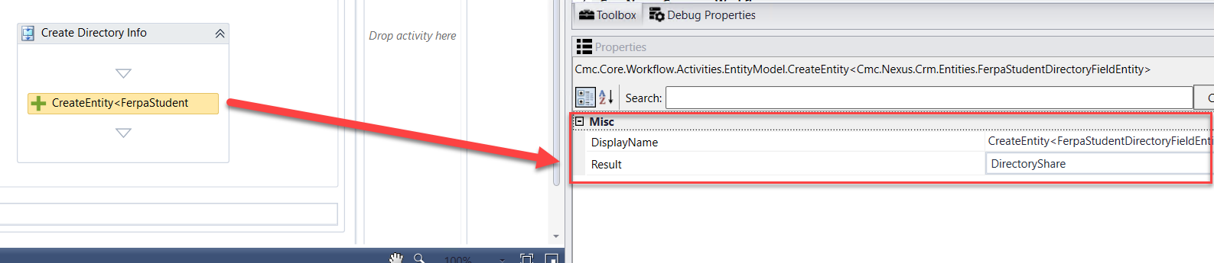

1. Drag two ***Assign*** activities onto the Designer below the ***CreateEntity FerpaStudentDirectoryFieldEntity*** activity. Update the properties as follows:

* ***Display Name***:  ***Map Id***; ***DirectoryShare.StudentId=StudentRelationshipAddressEntity.StudentId***
* ***Display Name: Assign Id;***

***DirectoryShare.FerpaDirectoryFieldId=count***

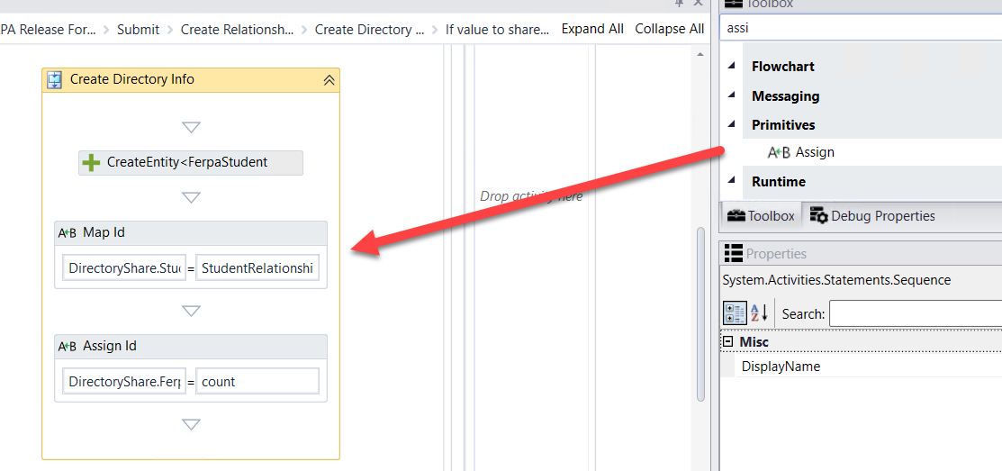

1. Drag the ***SaveEntity*** activity below the ***Assign Id Assign*** activity.

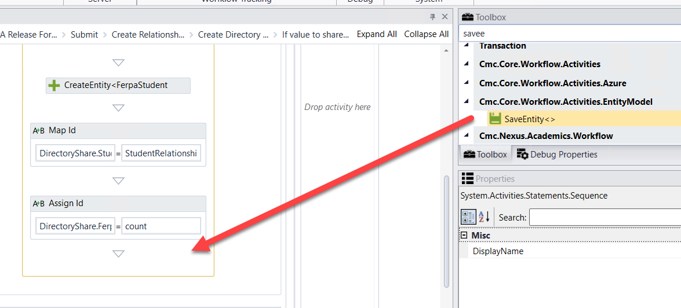

1. ***Browse for Type: Cmc.Nexus.Crm.Contracts>Cmc.Nexus.Crm.Entities>FerpaStudentDirectoryFieldEntity and Click OK***





1. Complete the properties as shown below.

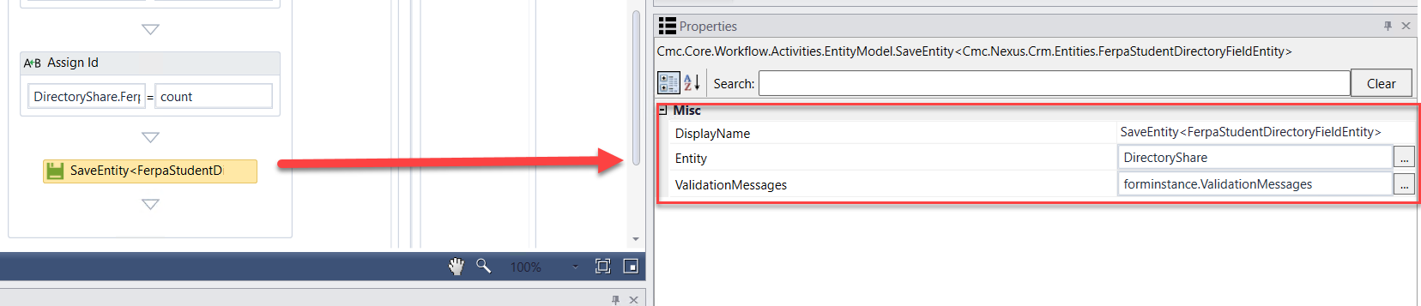

1. Drag an ***Assign*** activity below the ***SaveEntity FerpaStudentDirectoryFieldEntity*** activity. Update the activity as follows:

* ***Rename: Assign count increment***
* ***count=count+1***

**Note: Our count starts at 1 and we are going to increment by 1 until we reach 16. This will create all 16 Id's in the student relationship table.**

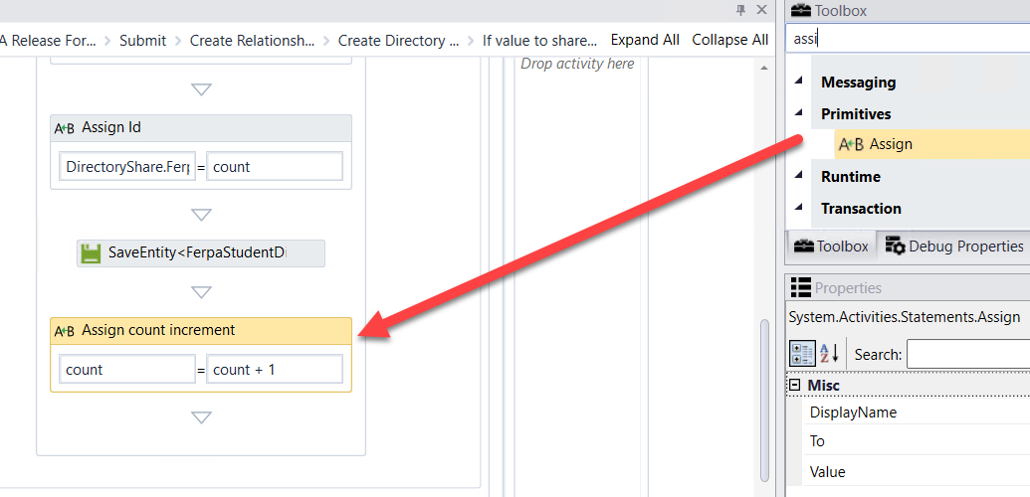

1. Drag an ***If*** activity into the ***Create Directory Info Sequence*** activity.

* Rename the activity to: ***If value to not share is true***
* Condition: ***myAckNot=True***

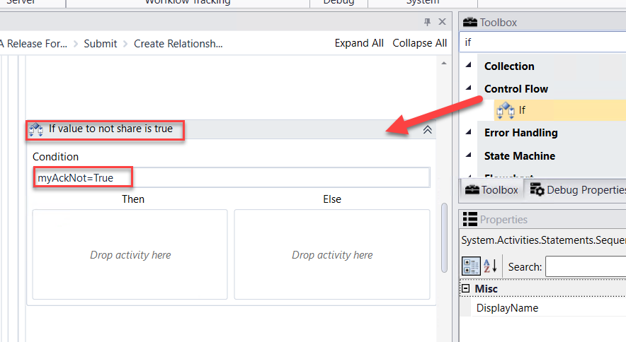

1. Drag an ***ExecuteQuery*** activity into the ***Then*** portion of the ***If value to not share is true If*** activity. Update the following for the activity:

* ***Rename: Delete directory records***
* ***Command: "delete from CmFERPADirStudentRelation where systudentid = " & studentid***

**Note: If the student selects to NOT release directory information then any records that are in the student relationship table will be removed.**

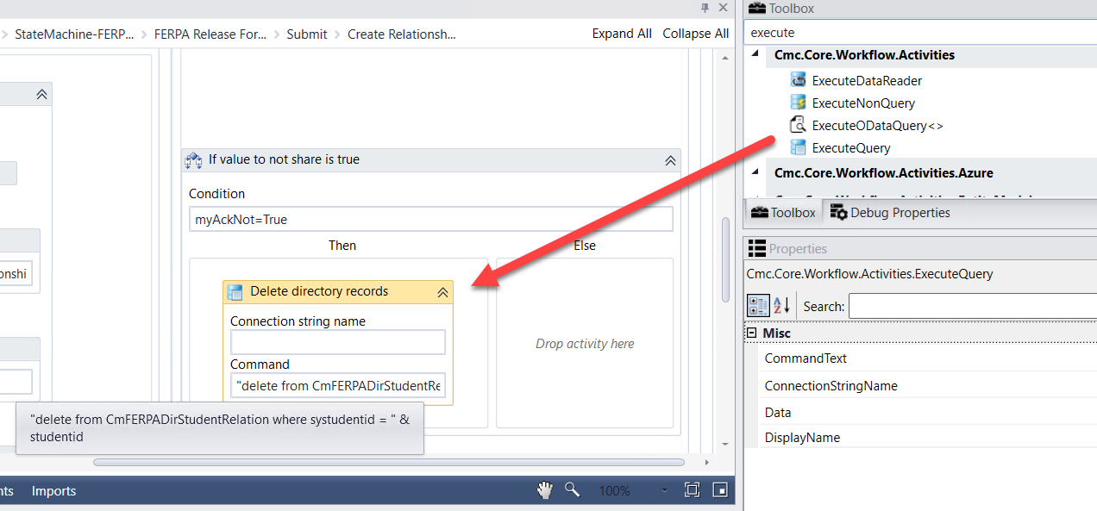

1. Drag a ***CreateEntity*** activity in the ***Create FERPA Info Sequence*** activity.

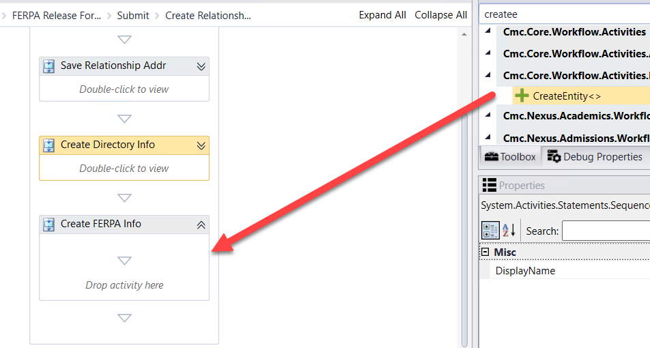

1. ***Browse for Type: Cmc.Nexus.Crm.Contracts>Cmc.Nexus.Crm.Entities>FerpaStudentRelationshipEntity and Click OK***



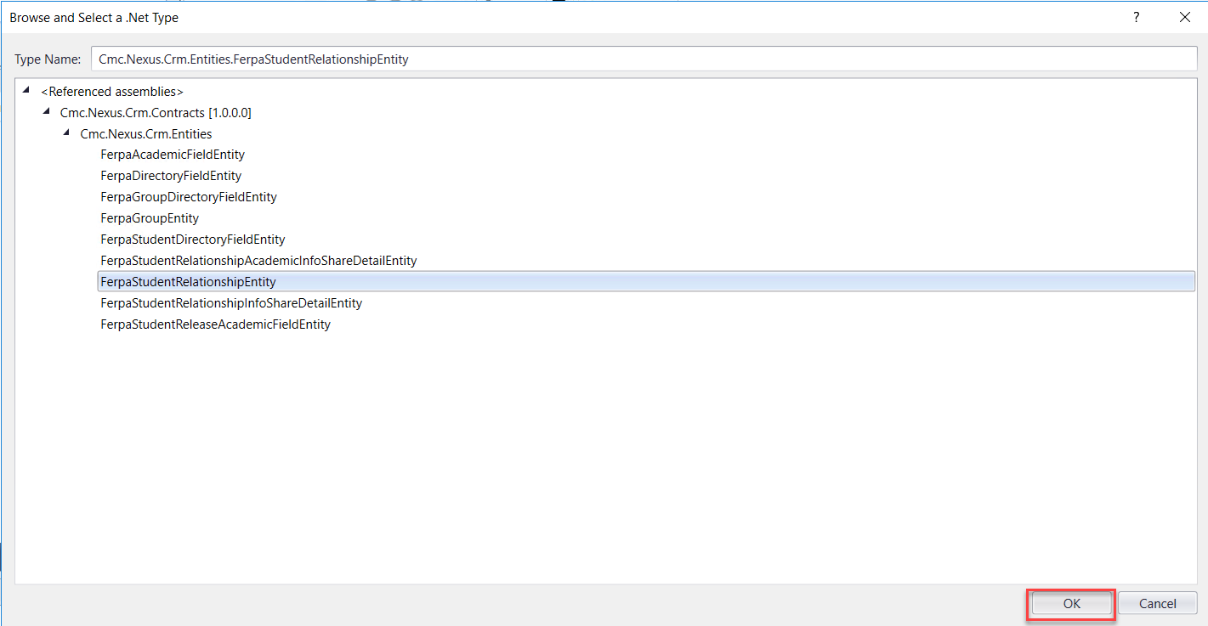

1. Complete the properties as shown below.

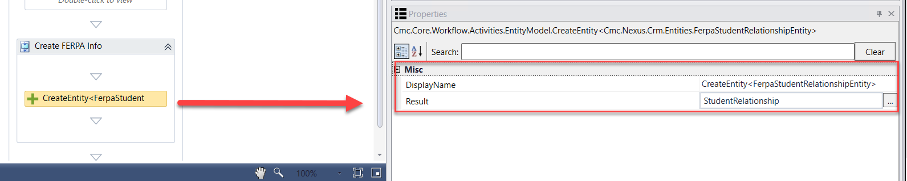

1. Drag five ***Assign*** activities onto the Designer below the ***CreateEntity FerpaStudentRelationshipEntity*** activity. Update the properties as follows:

* ***Display Name***:  ***Map Address Id***; ***StudentRelationship.StudentRelationshipAddressId=studentRelationshipAddressEntity.Id***
* ***Display Name: Assign Description;***

***StudentRelationship.Description="Form Submission"***

* ***Display Name: Assign Share Info Start Date;***

***StudentRelationship.ShareInfoStartDate=datetime.Today***

* ***Display Name: Assign Share Info End Date;***

***StudentRelationship.ShareInfoEndDate=datetime.Today.AddMonths(12)***

* ***Display Name: Assign as Active Record;***

***StudentRelationship.IsActive=True***

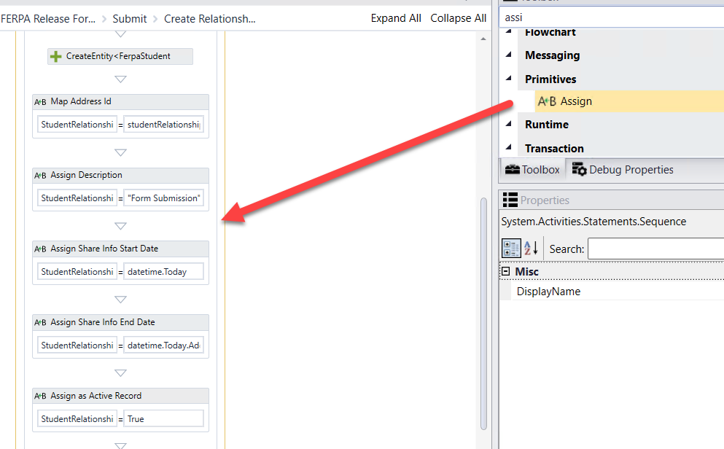

1. Drag a ***Sequence*** activity below the ***Assign as Active Record Assign*** activity. Rename the activity to: ***Academic Info to Share***

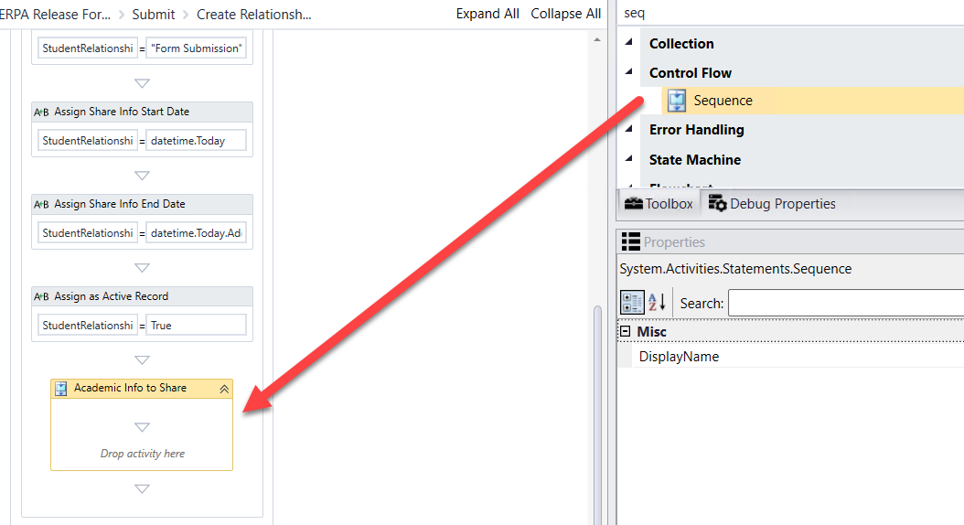

1. Drag an ***Assign*** activity into the ***Academic Info to Share Sequence*** activity. Complete the activity as follows:

* Rename the activity: ***Assign Initial Count***
* ***count=0***

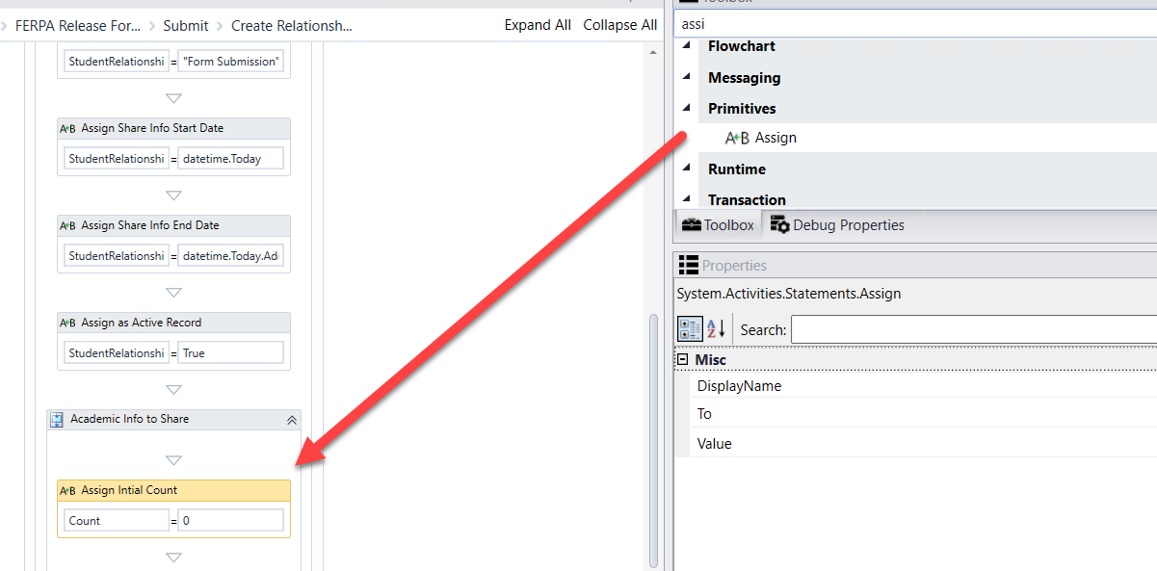

1. Drag a ***DoWhile*** activity below the ***Assign Initial Count Assign*** activity. For the ***Condition*** enter the following: ***count<8***

**Note: There are 8 directory Id's in the table. We are going to loop through and add each one as selected/unselected based on the selection on the form.**

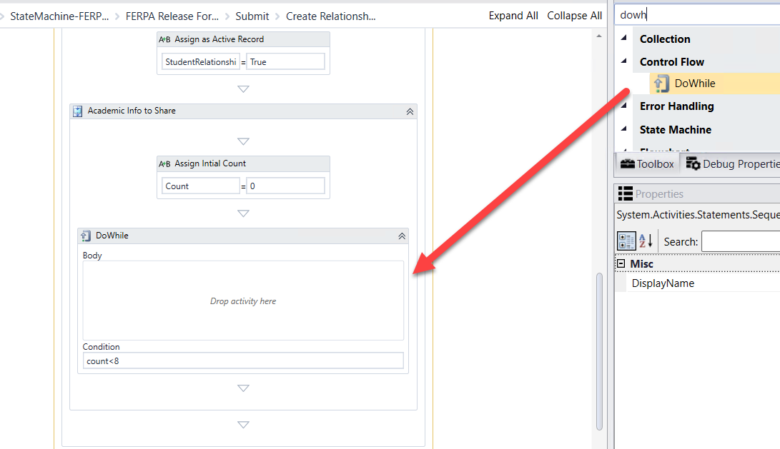

1. Drag a ***Sequence*** activity into the ***Body*** of the ***DoWhile*** activity. Rename the activity to:

***Save AD Directory Info***

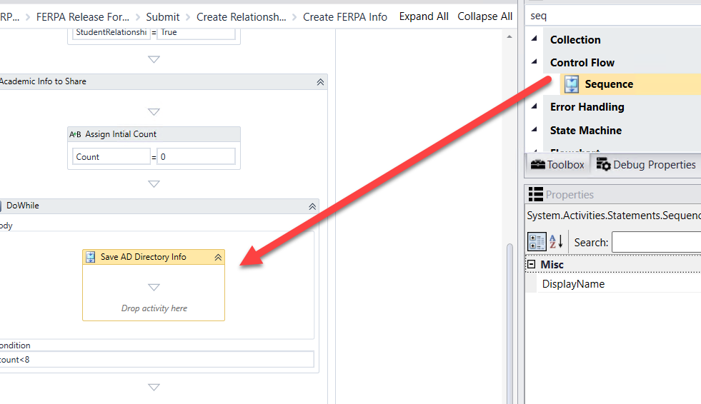

1. Drag an ***If*** activity into the ***Save AD Directory Info Sequence*** activity.

* Rename the activity to: ***If selected, create***
* Condition: ***mylist(Count)***

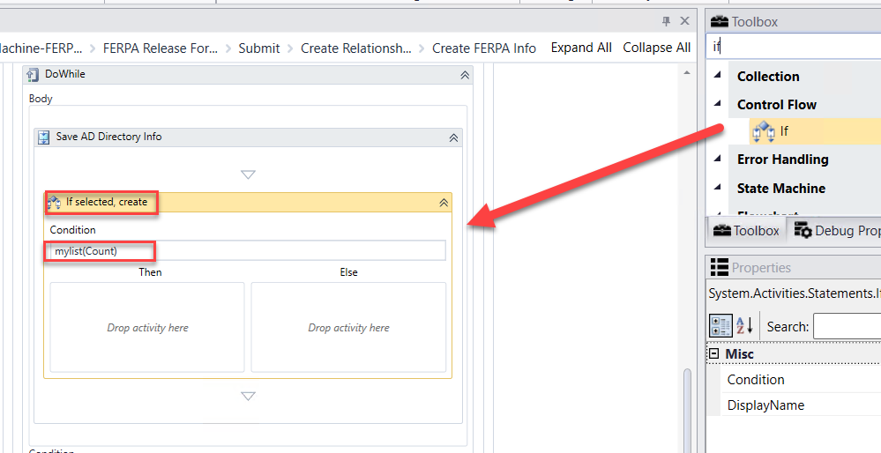

1. Drag a ***Sequence*** activity into the ***Then*** portion of the ***If*** activity. Rename the activity to: ***Loop,create AD Directory***

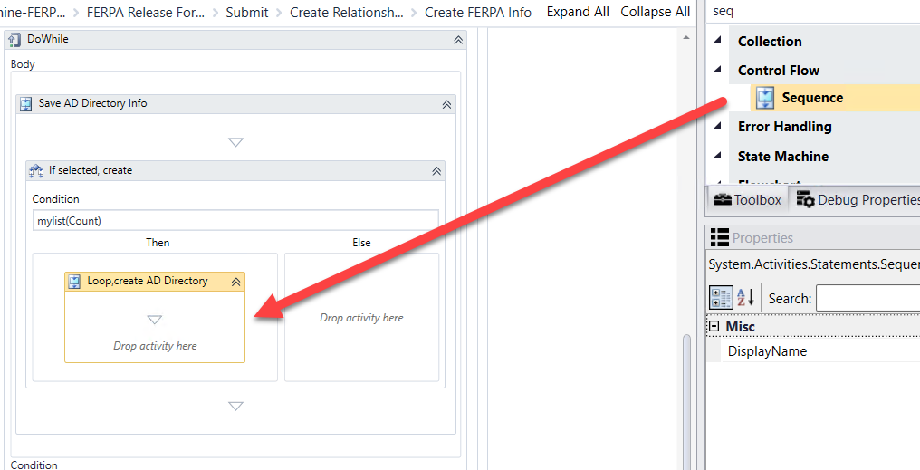

1. Drag a ***CreateEntity*** activity in the ***Loop,create AD Directory Sequence*** activity.

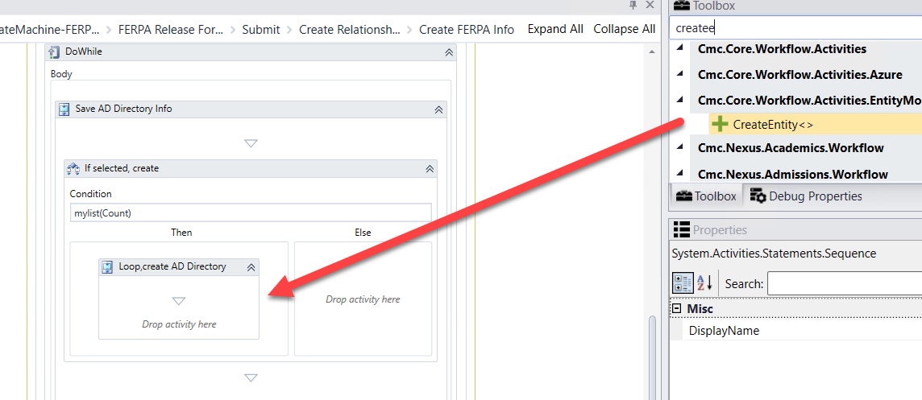

1. ***Browse for Type: Cmc.Nexus.Crm.Contracts>Cmc.Nexus.Crm.Entities>FerpaStudentReleaseAcademicFieldEntity and Click OK***



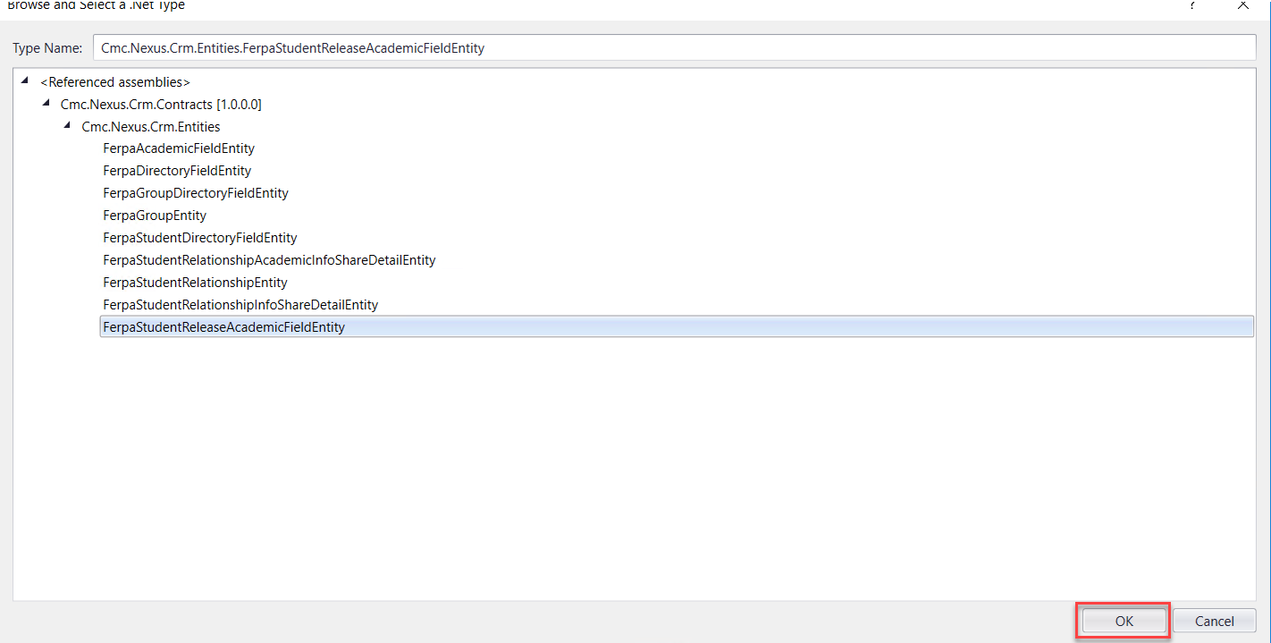

1. Complete the properties as shown below.

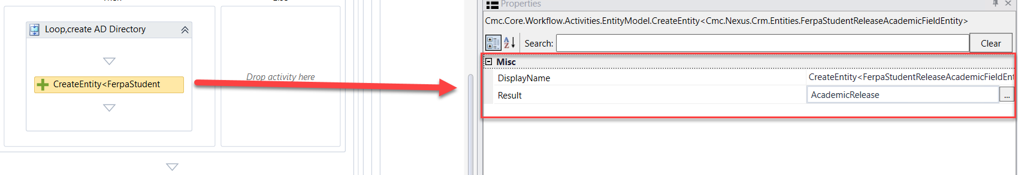

1. Drag an ***Assign*** activity onto the Designer below the ***CreateEntity FerpaStudentReleaseAcademicFieldEntity*** activity. Update the properties as follows:

* ***Display Name***:  ***Assign Id***; ***AcademicRelease.FerpaAcademicFieldId=count +1***

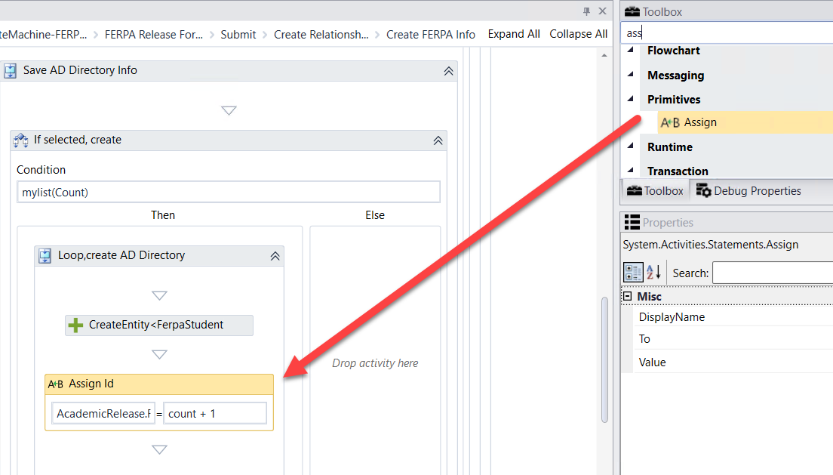

1. Drag the ***AddToCollection*** activity below the ***Assign Id Assign*** activity.

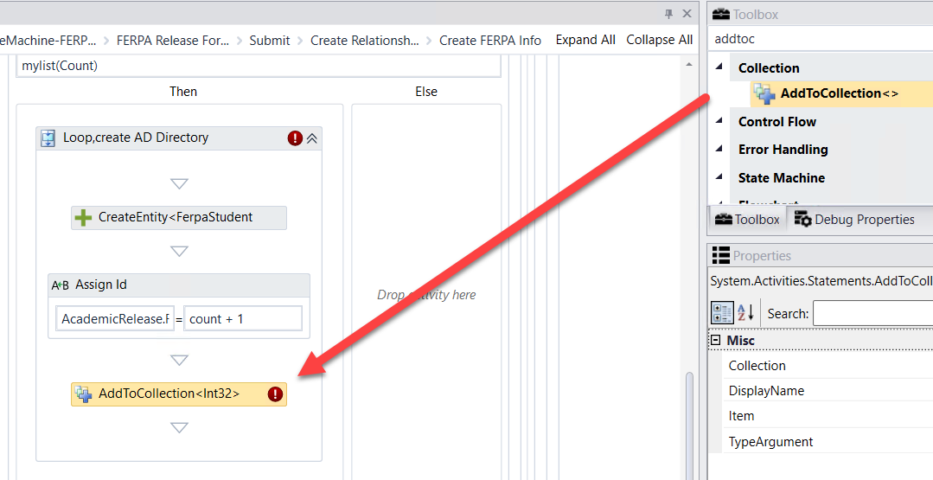

1. Update the properties for the activity as shown below:

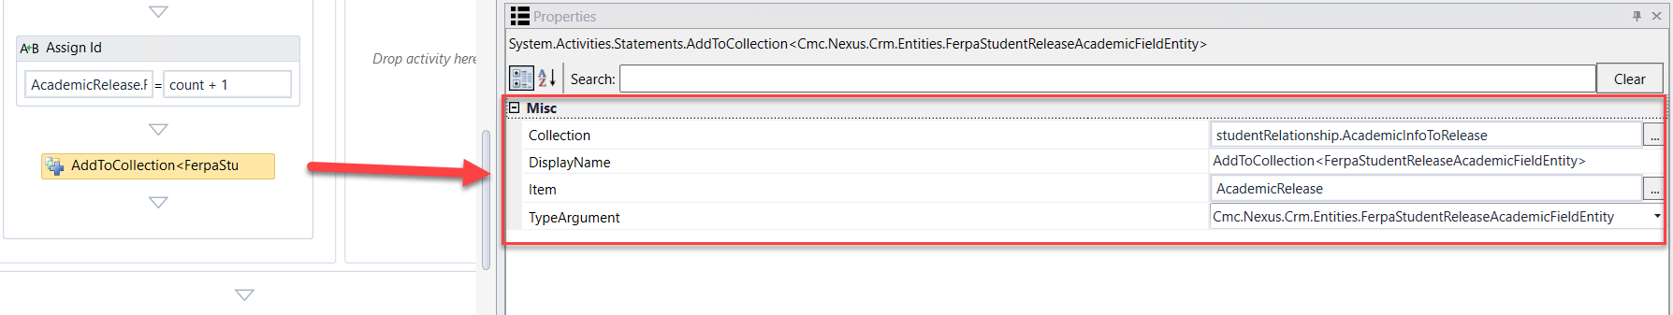

1. Drag an ***Assign*** activity onto the Designer below the ***If selected, create If*** activity. Update the properties as follows:

* ***Display Name***:  ***Assign count increment***; ***count=count +1***

**Note:** Our count starts at 0 and we are going to increment 0 + 1 until we reach 8. This will create any of the 8 Id's based on the selection in the form.

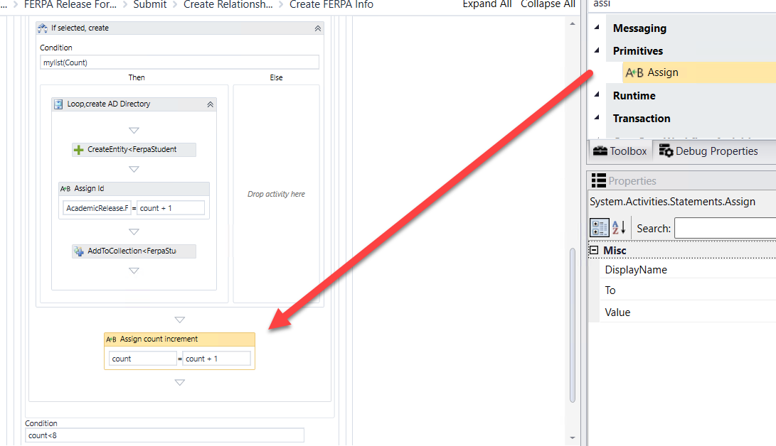

1. Drag the ***LogObject*** activity below the  ***Condition*** of the ***DoWhile*** activity. Update the properties for the activity as shown below:

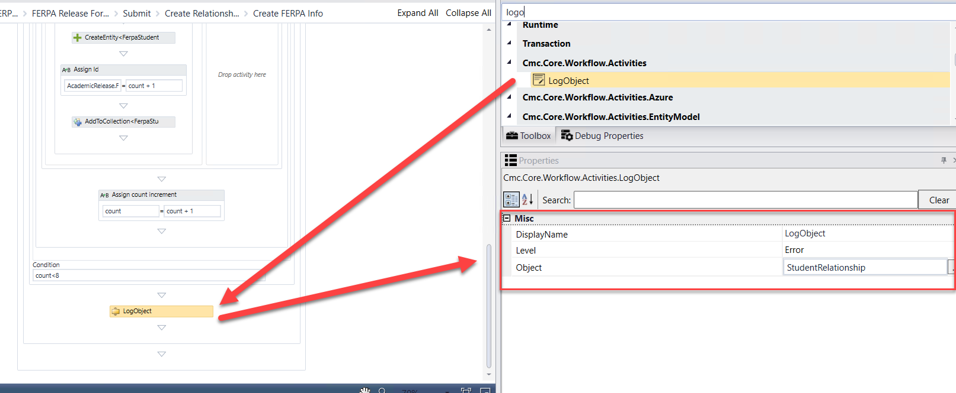

1. Drag the ***SaveEntity*** activity below the ***LogObject*** activity.

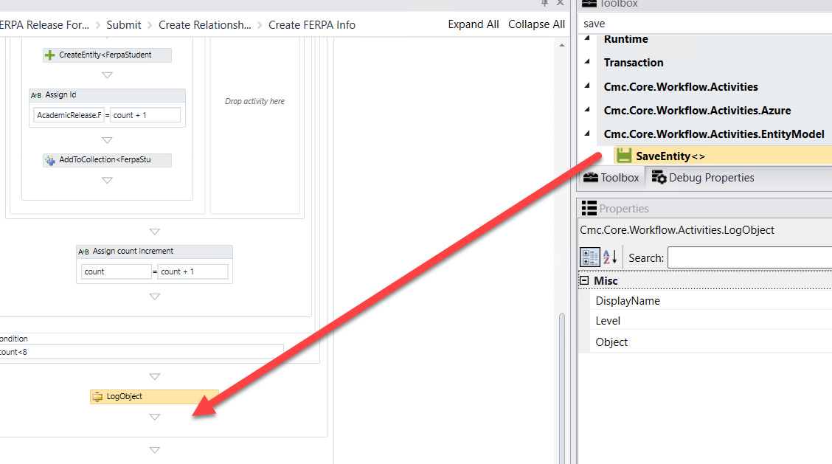

1. ***Browse for Type: Cmc.Nexus.Crm.Contracts>Cmc.Nexus.Crm.Entities>FerpaStudentRelationshipEntity and Click OK***



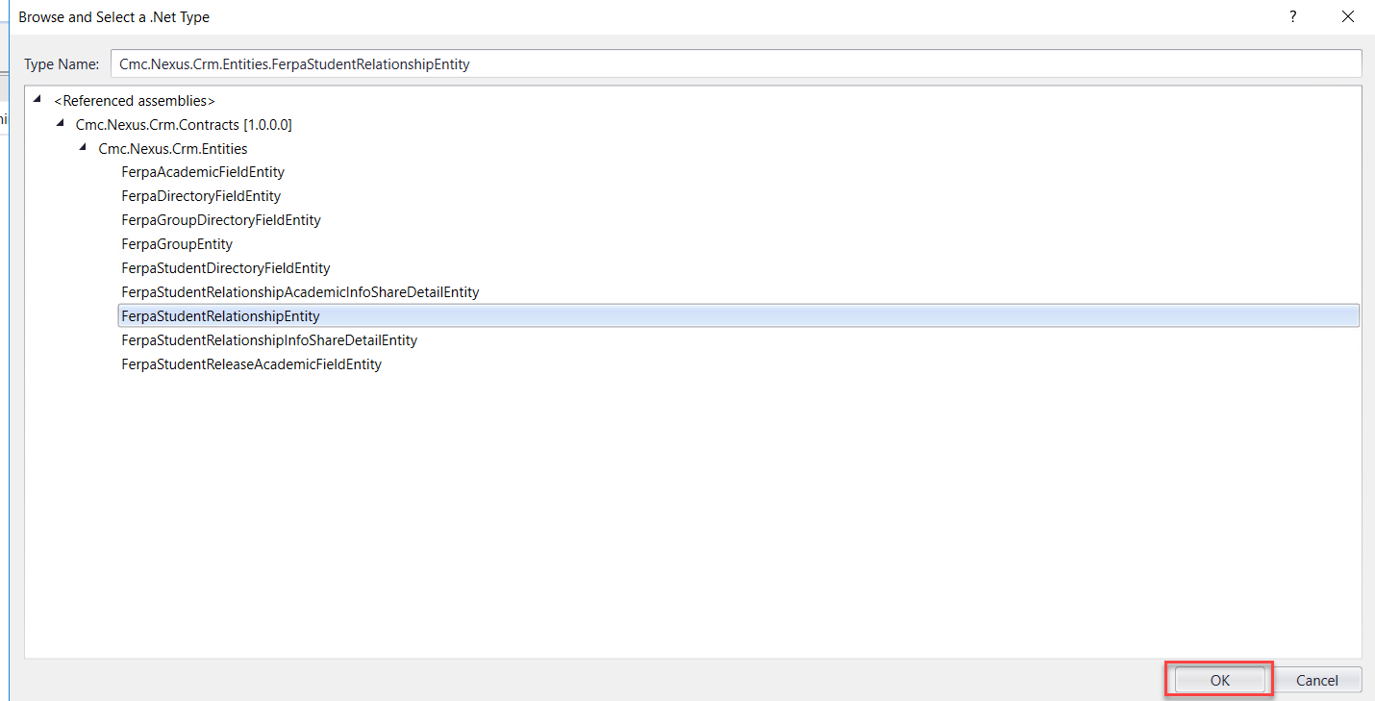

1. Complete the properties as shown below.

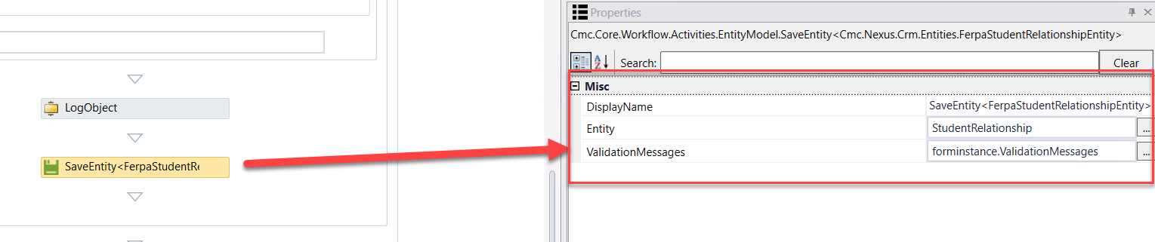

1. Confirm there are no Errors in the Error pane.

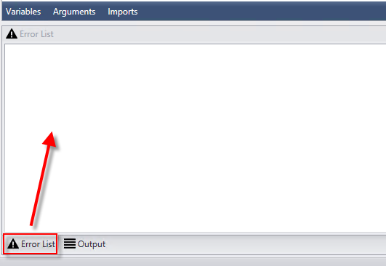

1. ***Save*** your Workflow to: ***C:\CampusNexus\Insight2019***

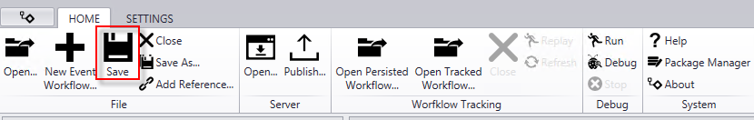

1. ***Publish*** your Workflow. Make sure you select ***Enable This Workflow Version?*** and select ***Publish*.** Select ***OK*** to the confirmation.

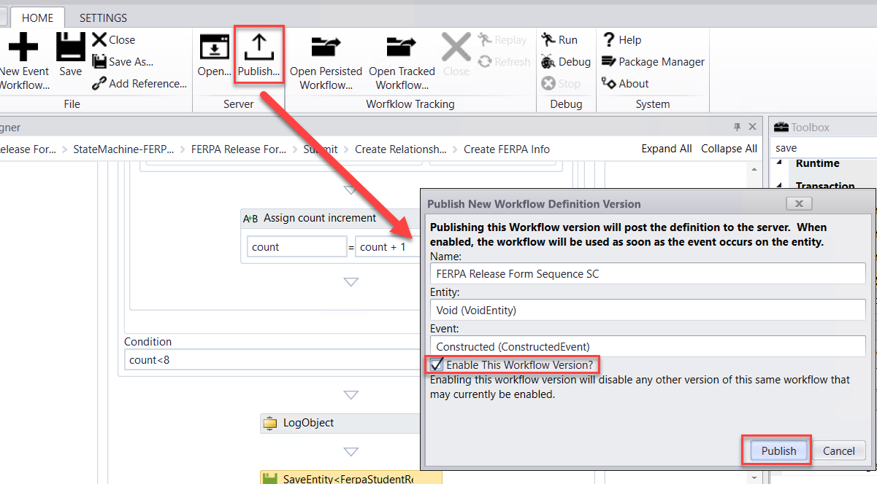

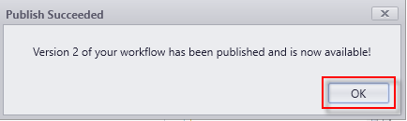

# Lesson 2: Validate the Form and Supporting Workflow

In this lesson, you will validate the FERPA Process by logging in as a student and completing the FERPA Release Form Sequence. You will then validate the student record in the CampusNexus Web Client to ensure the correlating data was updated

## Exercise: Validate the Student Self-Service Form and Supporting Workflow for the FERPA Process

1. Navigate to ***Google Chrom*e** and launch ***Student*** from the ***Bookmarks Bar***.



1. ***Sign in*** using the following credentials:

***administrator***

***testing***

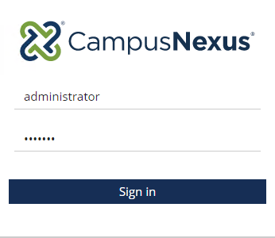

1. Select ***Students*.**



1. Search for student ***Anna Rizzo*** and click on the student link to open the student record.

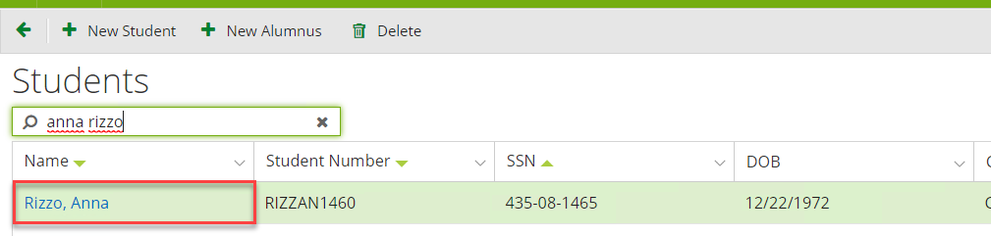

1. Validate ***Data Block Indicator (FERPA)*** has not been selected for the student.

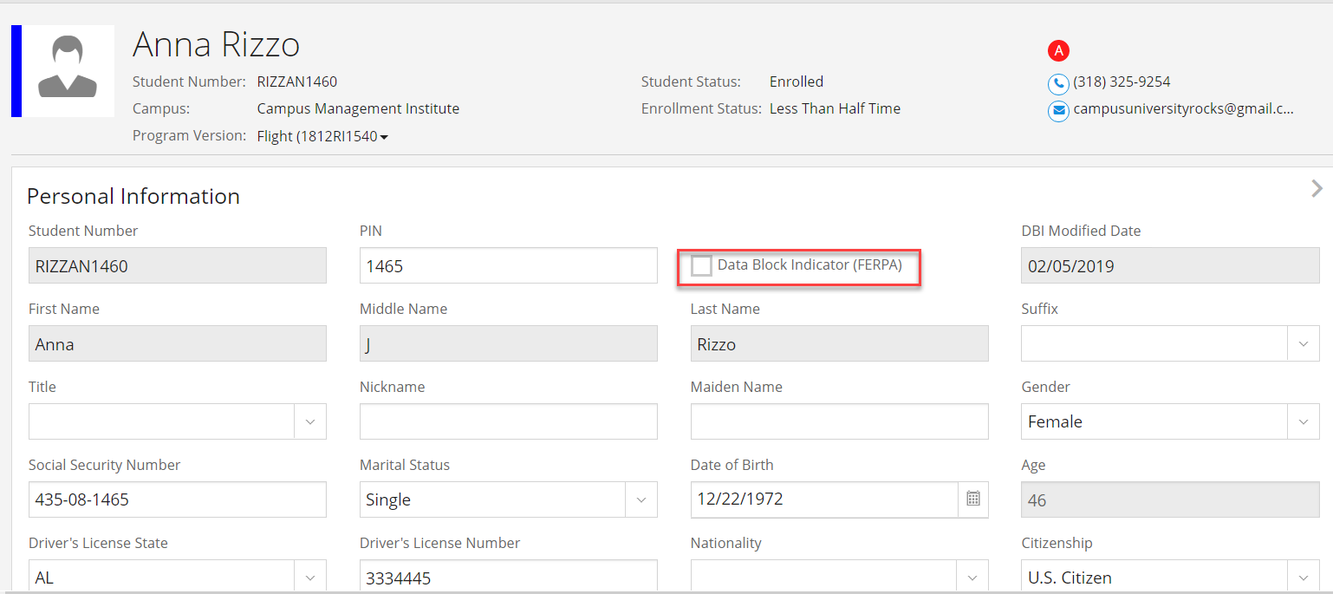

1. Navigate to ***FERPA*** under ***Contact Manager.*** Validate no FERPA information is added for the student.

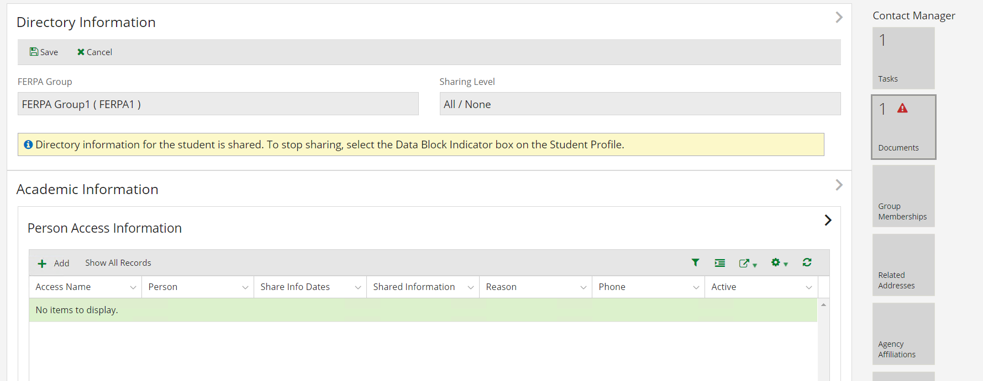

1. Open ***Google Chrome*** and launch ***Renderer*** from the ***Bookmarks Bar***.



1. Find your ***FERPA Release Form Sequence*** in the list and click the ***arrow*** to navigate to the sequence.

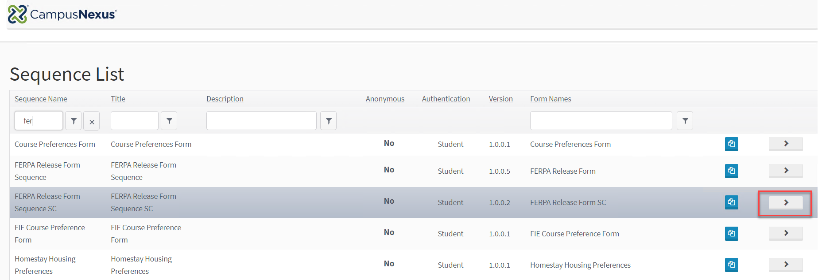

1. Login as the student:

***Username: anna.rizzo***

***Password: nexus123***

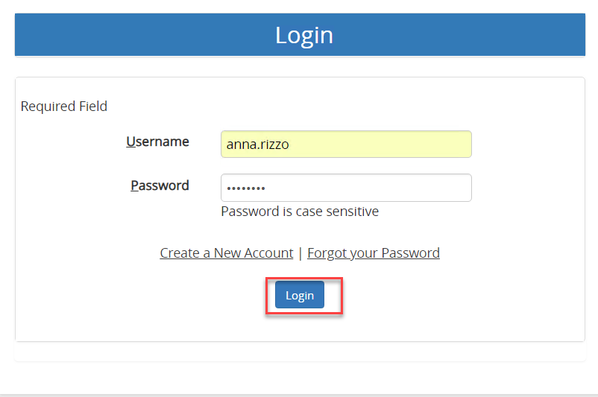

1. Complete the ***FERPA Release Form*** as shown below:

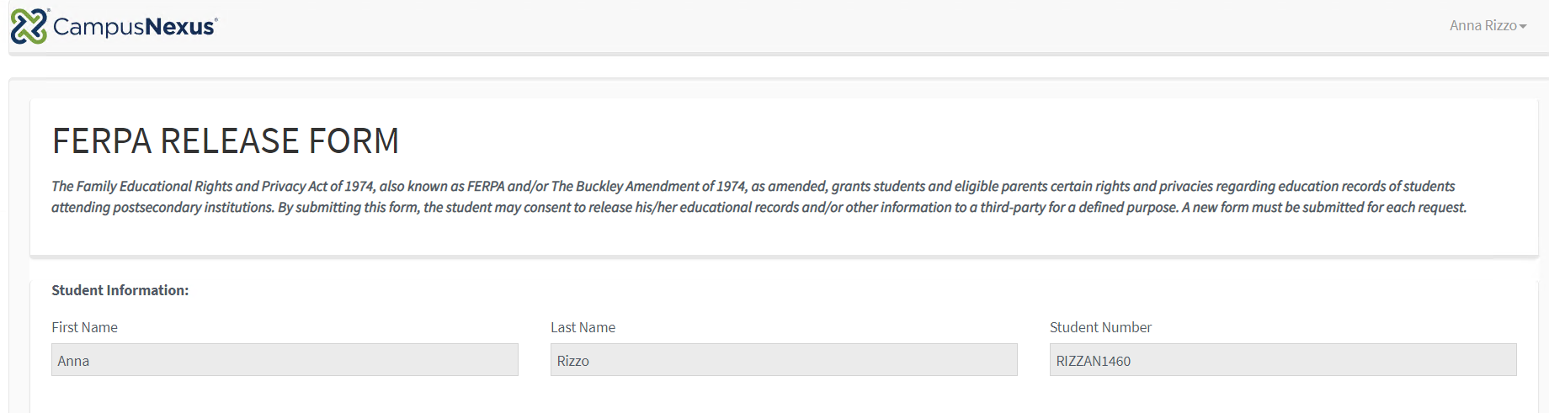

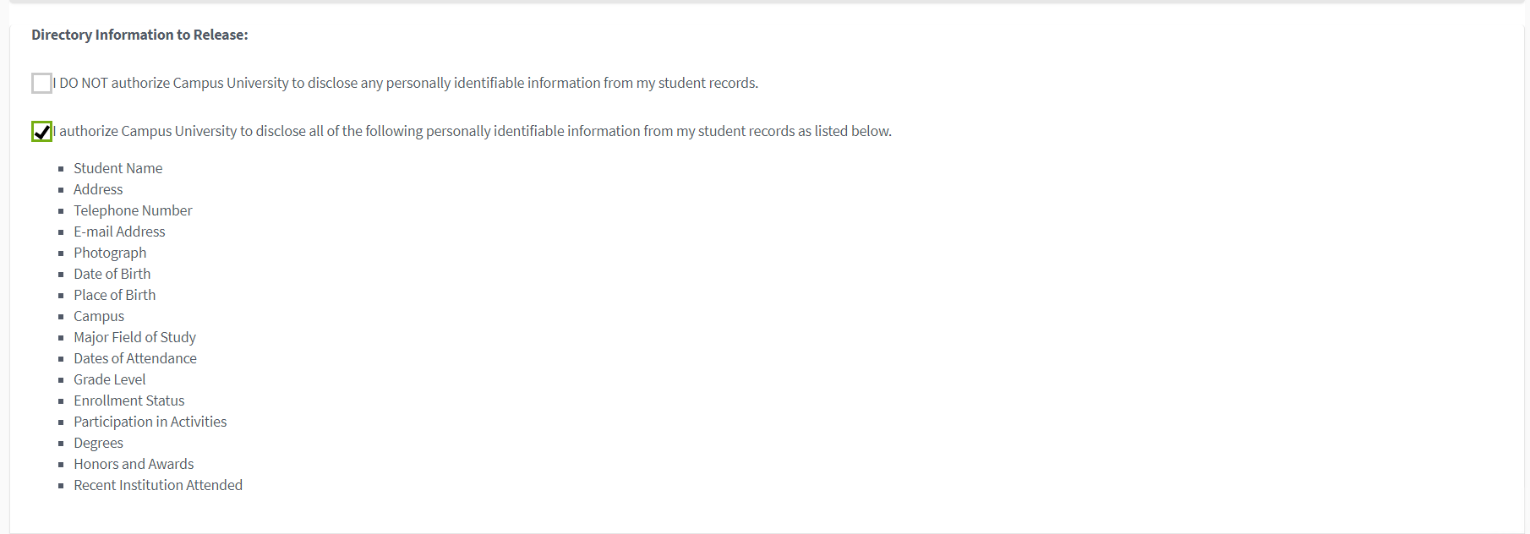

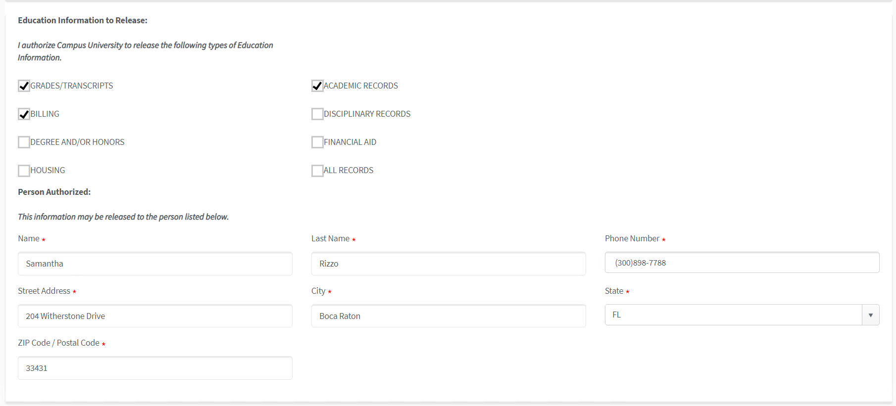



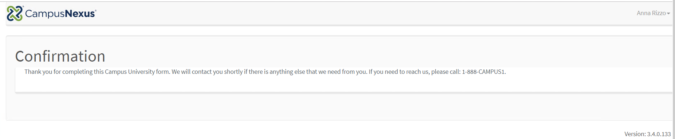

1. Navigate back to ***CampusNexus Student*** and verify the ***Data Block Indicator (FERPA) is now checked and the FERPA icon is displayed on the student record.***

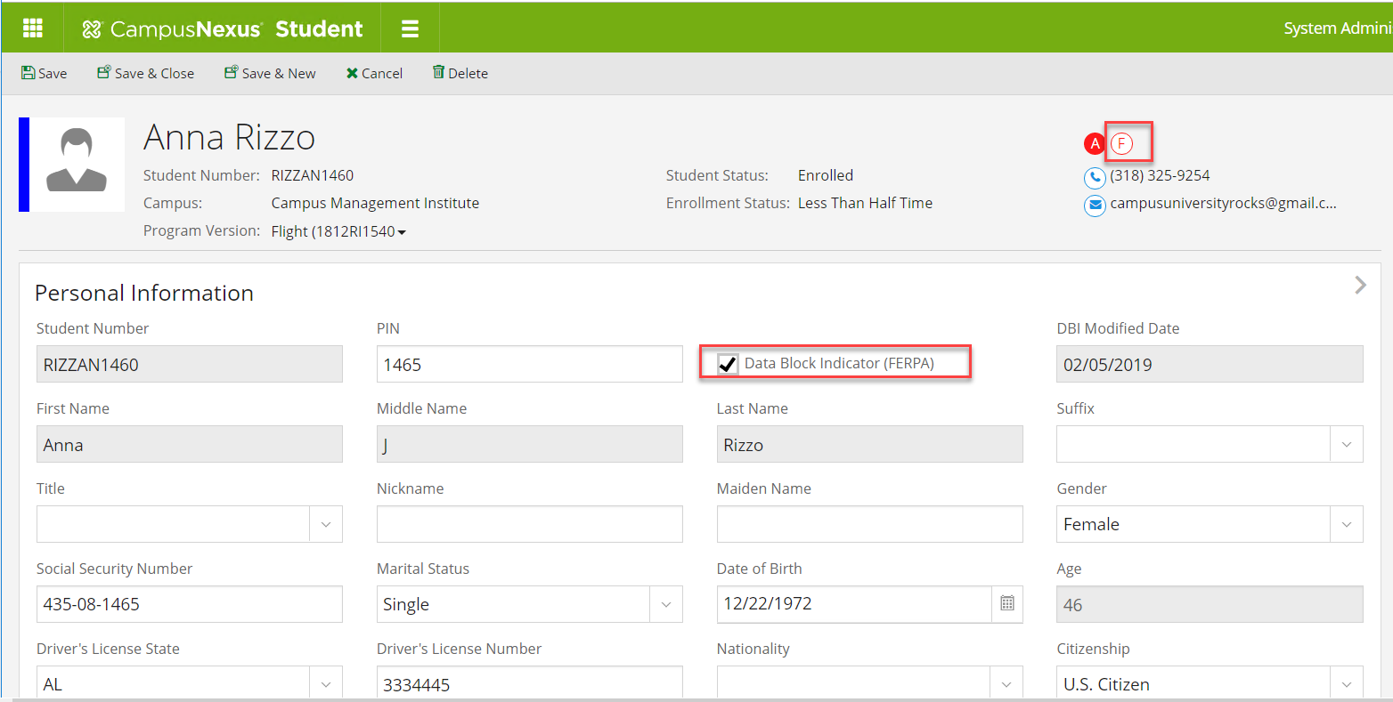

1. Navigate to ***FERPA*** under ***Contact Manager.*** Validate FERPA information is added for the student.

